**Tuesday, February 06, 2024**

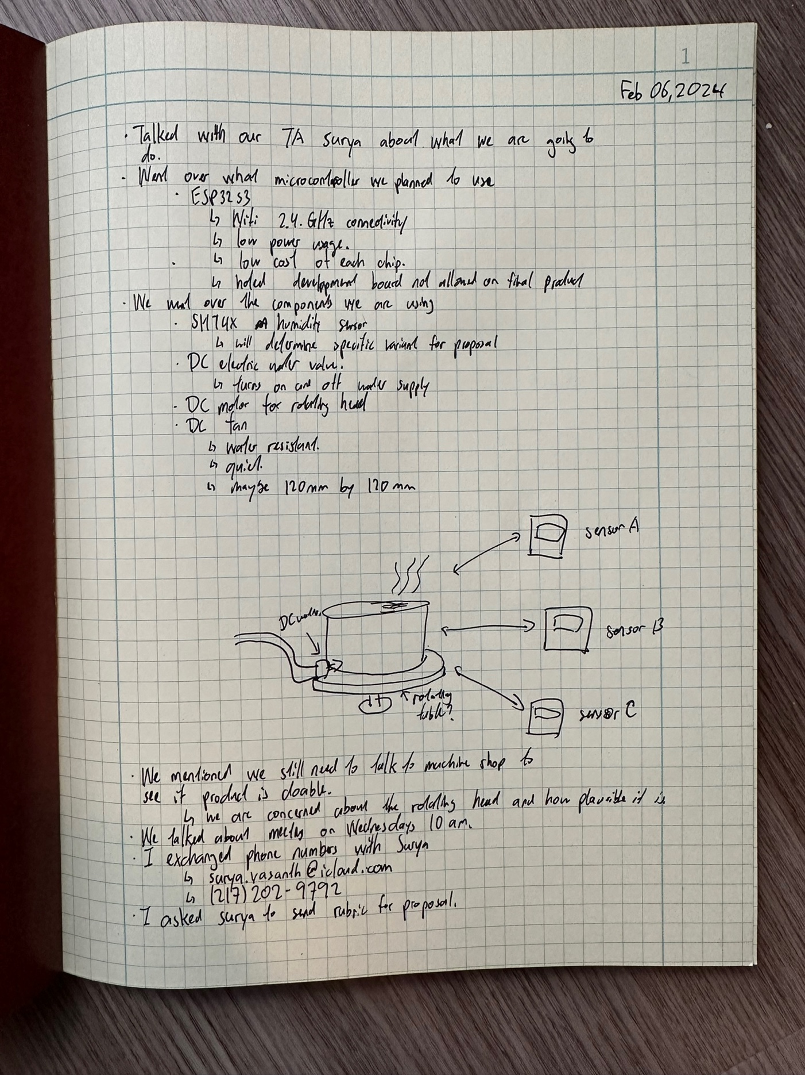

**Wednesday, February 07, 2024**

Today, we talked to the machine shop. Prior to going, I made a PowerPoint describing what we wanted to do. In the PowerPoint, I included some images, such as a visual aid, and images of parts that we may use.

In the machine shop, Gregg told us that they will not build a new humidifier for us. However, they will be happy to modify one from Amazon. He suggests that we get one that is simple, with a manual on-off function. Also, it is preferred that it is square, so that it will be easier to mount things without leaks.

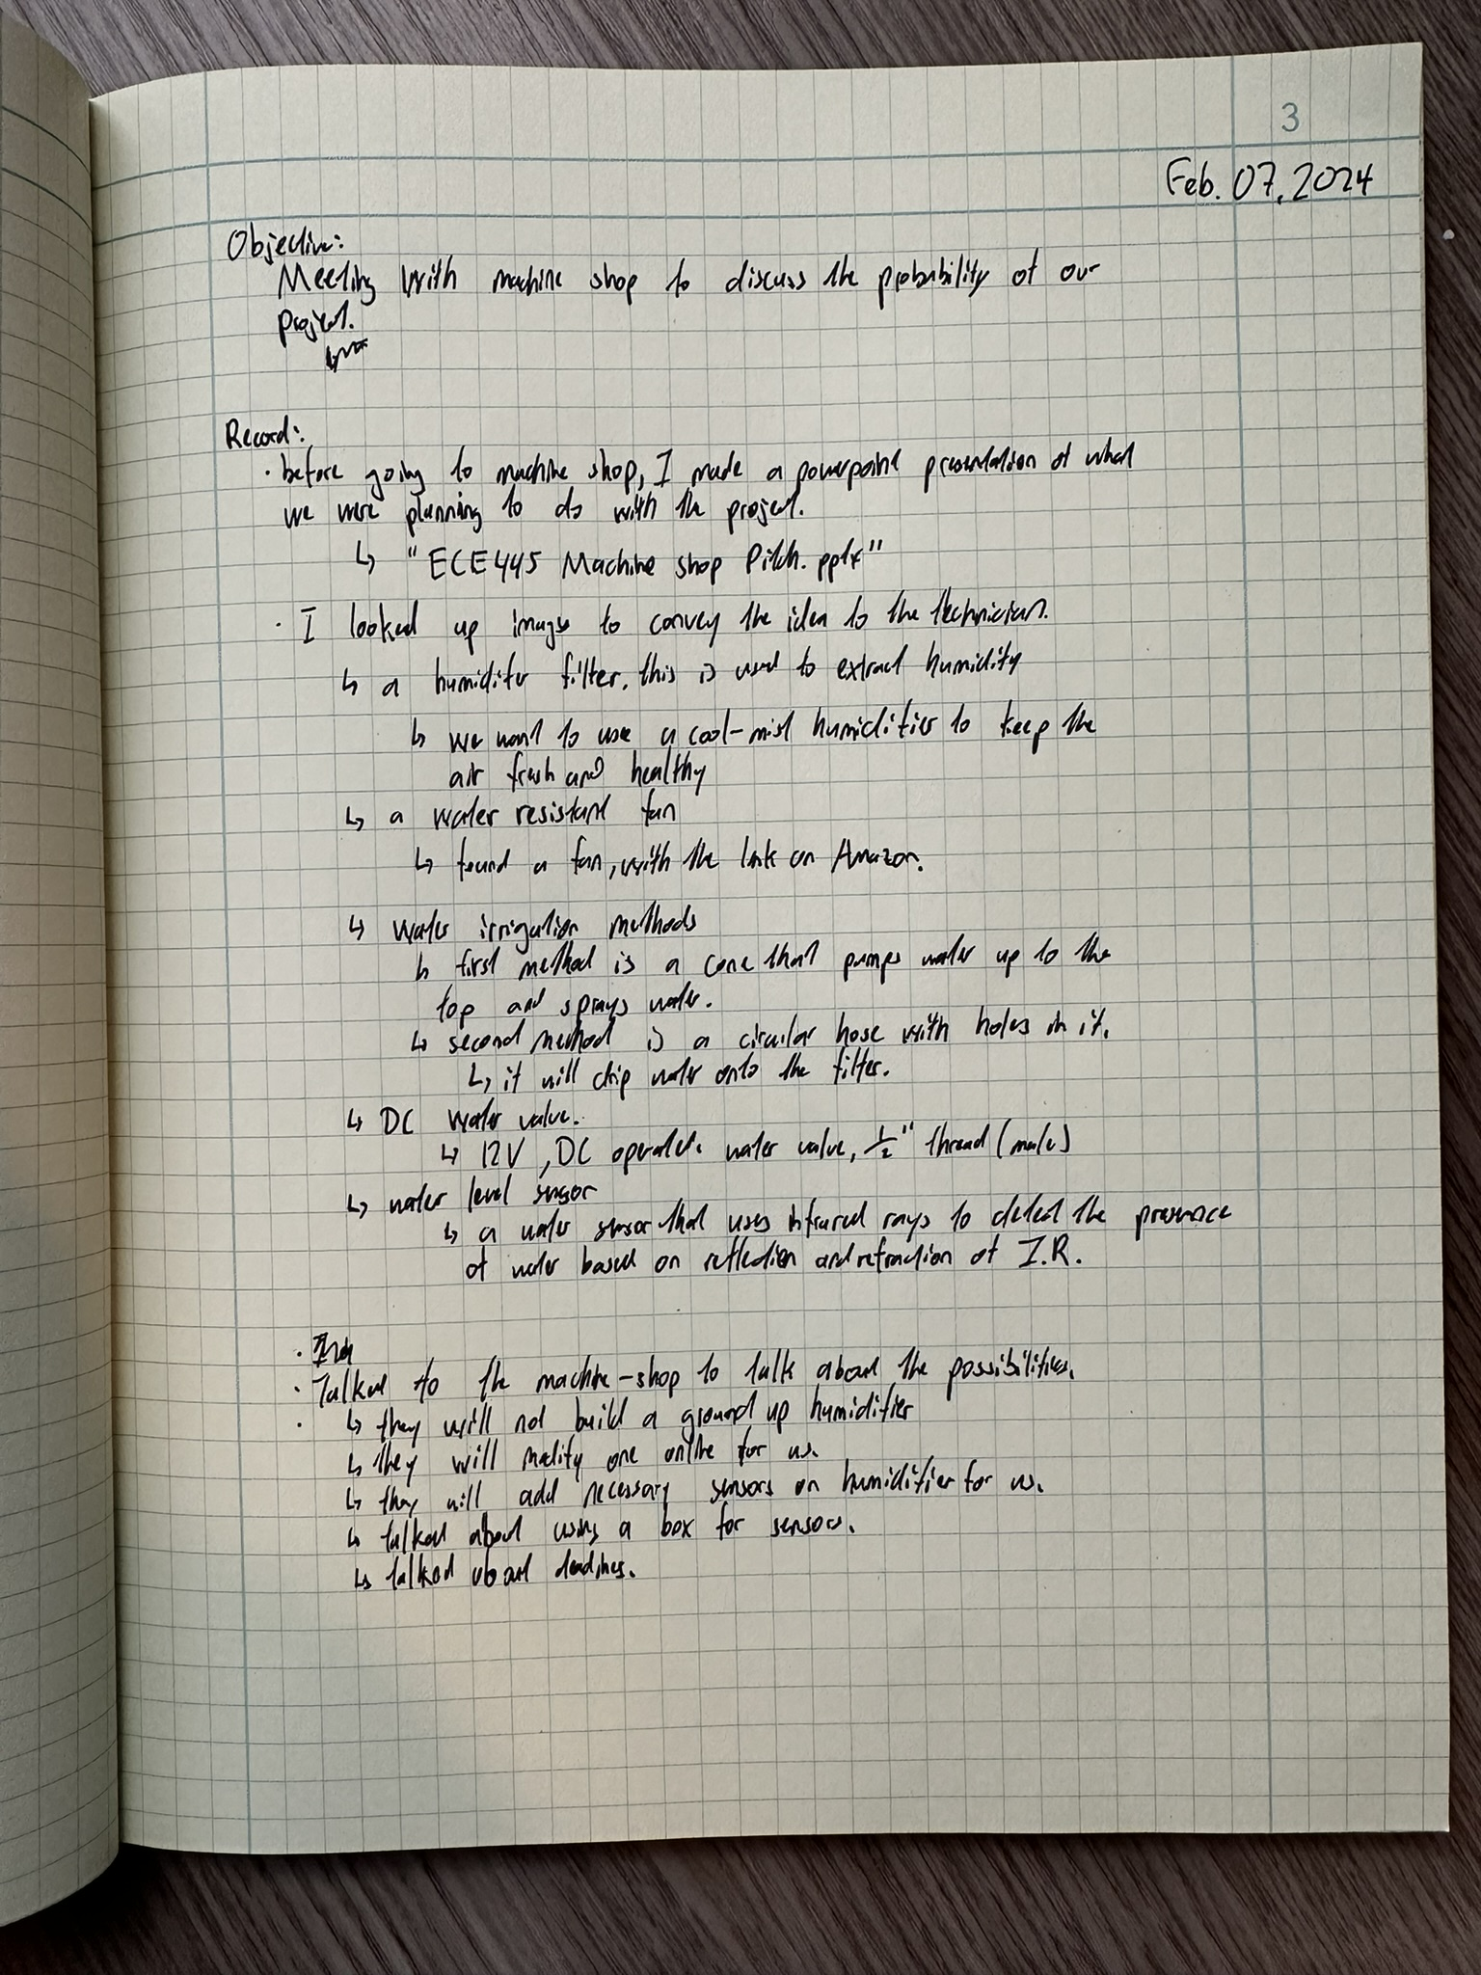

**Thursday, February 08, 2024**

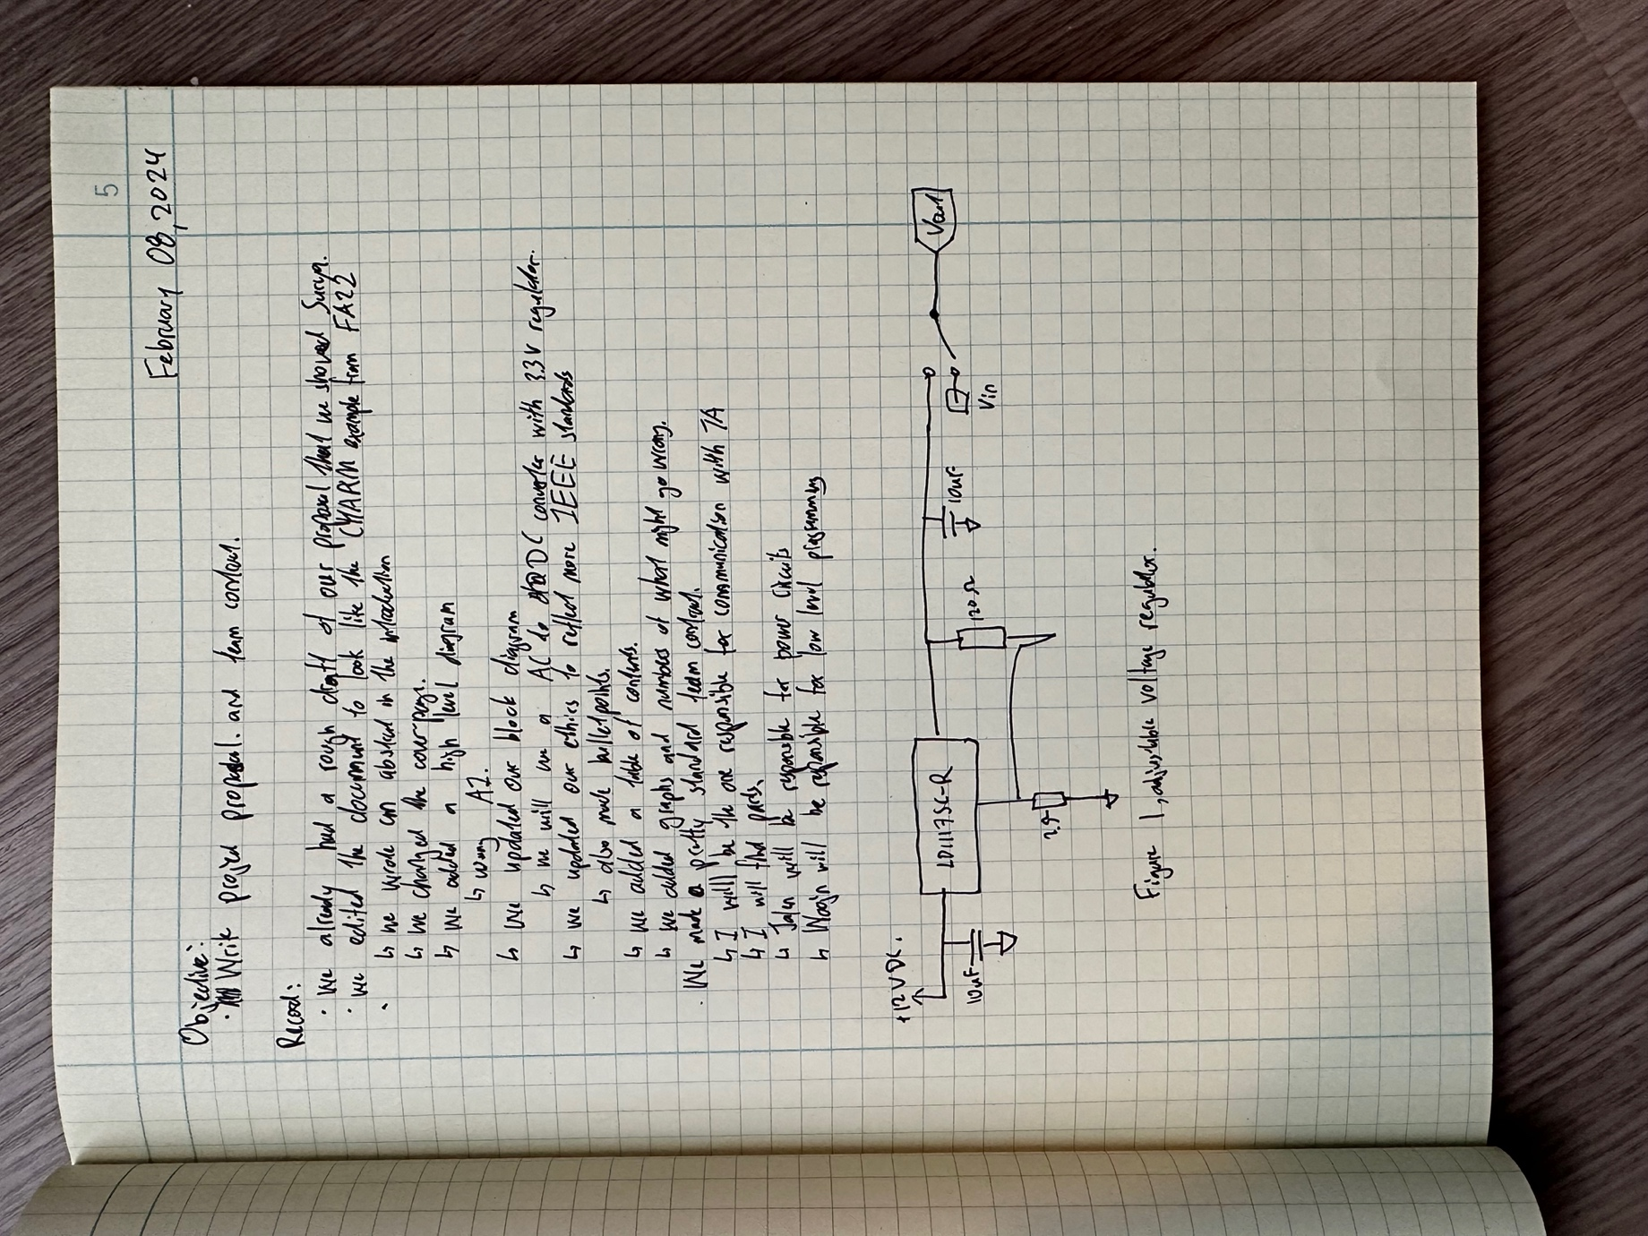

**Wednesday, February 14, 2024**

**Objective: Meeting with Surya, discuss machine shop, discuss using GitHub for journal**

Today we had a meeting with Surya. We went over our meeting with the machine shop. I told Surya that we are not able to have a rotating head as originally proposed. The reason is that the machine shop does not want to build a humidifier ground up for us. Also, the machine shop just wants to modify a humidifier to fit our needs. Surya told us to think of another high level to fill in for the rotating head. We said that we may do automatic water refilling. Surya also reminded us to sign up for the design review, which is opening on Friday.

I also asked Surya if, instead of writing physically on a journal, I can change to GitHub. He says yes, and to make sure to submit the journal at the end of the semester.

**Thursday, February 15, 2024**

**Objective: Pick part with Jalen, what sensor and ESP32 to use**

I worked to Jalen picking out parts for our project. We needed to figure out what water level sensor to use and what humidity sensor to use. We did a lot of research to see what sensors met our needs in price and in function. Also, we had to decide on what microcontroller we should use. There are many versions of the ESP32, and we need to decide on one.

After doing research, we are leaning on using the ESP32-S3-WROOM-1-N8. The reason for this is because we don’t need the extra DRAM from other versions, and the S3 has a UART-USB chip.

**Friday, February 16, 2024**

**Objective: Text Surya about buying ESP32 board**

Today, I texted Surya about ordering a development board. He says that there are some ESP32 development boards that we can check out in ECE445. He will get back to me about it next week. I told Surya that we will check it out in our meeting next week.

**Tuesday, February 20, 2024**

**Objective: Meet with Surya, discuss proposal, place order for sensor, rent ESP32 Dev Board**

Today we met with Surya. We talked about our progress with the project and the due dates coming up. Surya told us about our scores for our proposal report. It was a bit low, but he says we can still make changes to it and submit it on Friday. He says that the other TA who graded the paper was strict about the scores. We were missing some requirements, which we will update. He also told us to look at CHARM’s paper. We originally did that too, but this time we will also reference the rubric. We will continue working on the project. We told Surya we are in the process of picking parts for the project.

We told Surya that our new high level will be to read the water level and automatically fill the water tank.

Today, we also placed the order for our water level sensor. We chose the Optomax Digital Liquid Level Sensor as it seems easy to work with and is well waterproofed. The only downside is that it is $24.99. We only ordered one to make sure it works.

Aside from that, we borrowed 4 ESP32-S3 development boards from ECE445. Surya helped sign it out for us. Jason asked why we needed so many boards. We told Surya that I needed two to work on two ESP32’s communicating over Wi-Fi. Jalen needs one to work on the water level sensor and motor controller. Woojin needs one for the humidity sensor.

**Wednesday, February 21, 2024**

**Objective: Write design document, make table for parts and labor**

We worked on our design document today. Woojin, Jalen, and I had a Zoom call. We worked on the paper together. We wonder why this class takes so much time on the writing. It is more than 4 credit hours. We were able to transfer a lot of our paper from the proposal over to the design document. We also made an estimated labor table, as well as the estimated parts list as shown below:

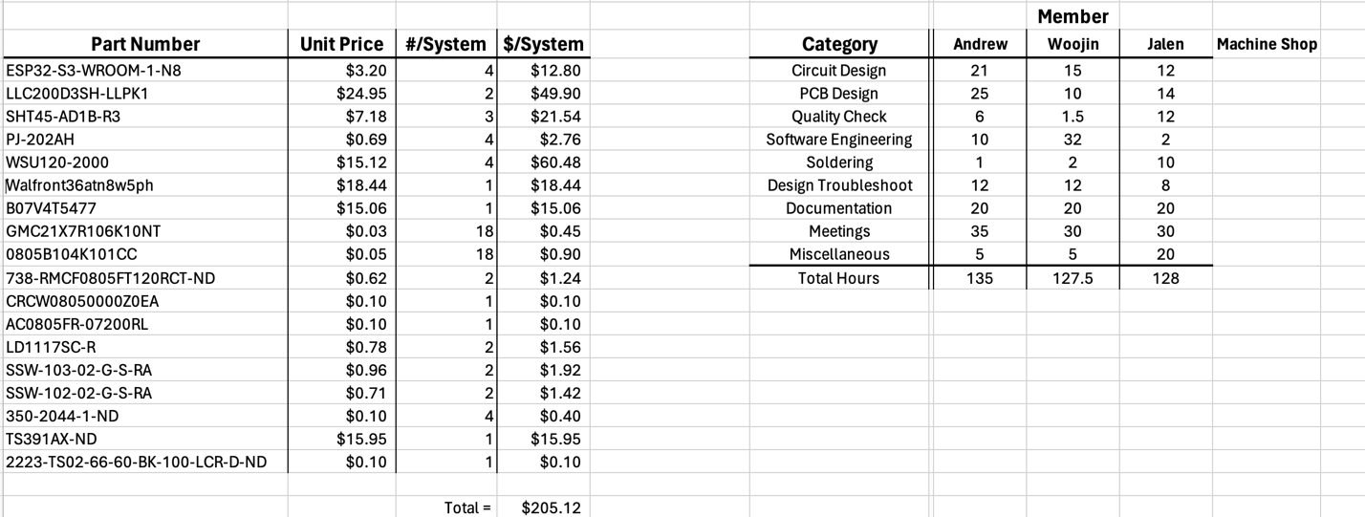

**Friday, February 23, 2024**

**Objective: Update proposal and rebsubmit**

Today, I worked on updating the proposal. I updated the block diagram on the proposal as well and the citations.

Later in the day, I started working on the PowerPoint for the design review on Wednesday next week.

**Monday, February 26, 2024**

**Objective: Ask Surya if schematics are needed for design review**

Today, I texted Surya if we needed schematic diagrams on our presentation. He says that we do not. So, I did not make any edits to our presentation.

**Wednesday, February 28, 2024**

**Objective: Present design review, meet Surya.**

Today, we the design review. There was no meeting for this week. Thanks for Surya, we dressed up for the design review and came prepared for the presentation. Professor Schuh did not ask us many questions. The only suggestions that he had were to include temperature in the algorithm for the humidifier, update the block diagram, and looks at built in humidifiers in houses for inspiration. Surya says that we were the first team to get full marks on the professionalism category.

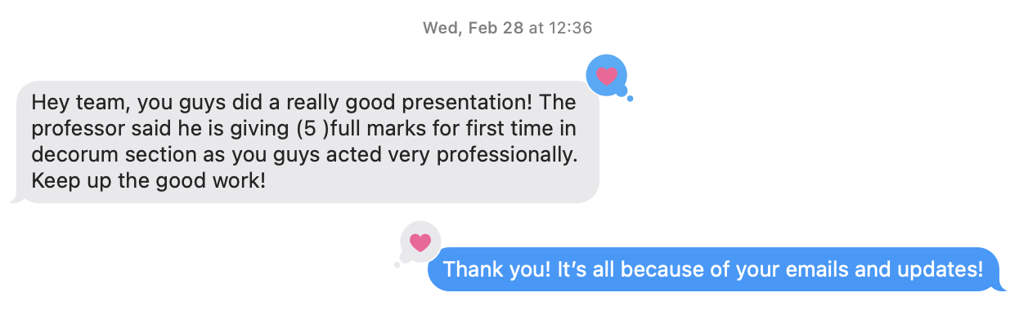

We went to a peer review, and they just read off their Google Doc. I am glad we make a PowerPoint.

I also made some edits to the block diagram. I updated the signals for the DC motor controller, as the ones in the proposal did not make sense. I also made the data and power lines more readable with new colors added.

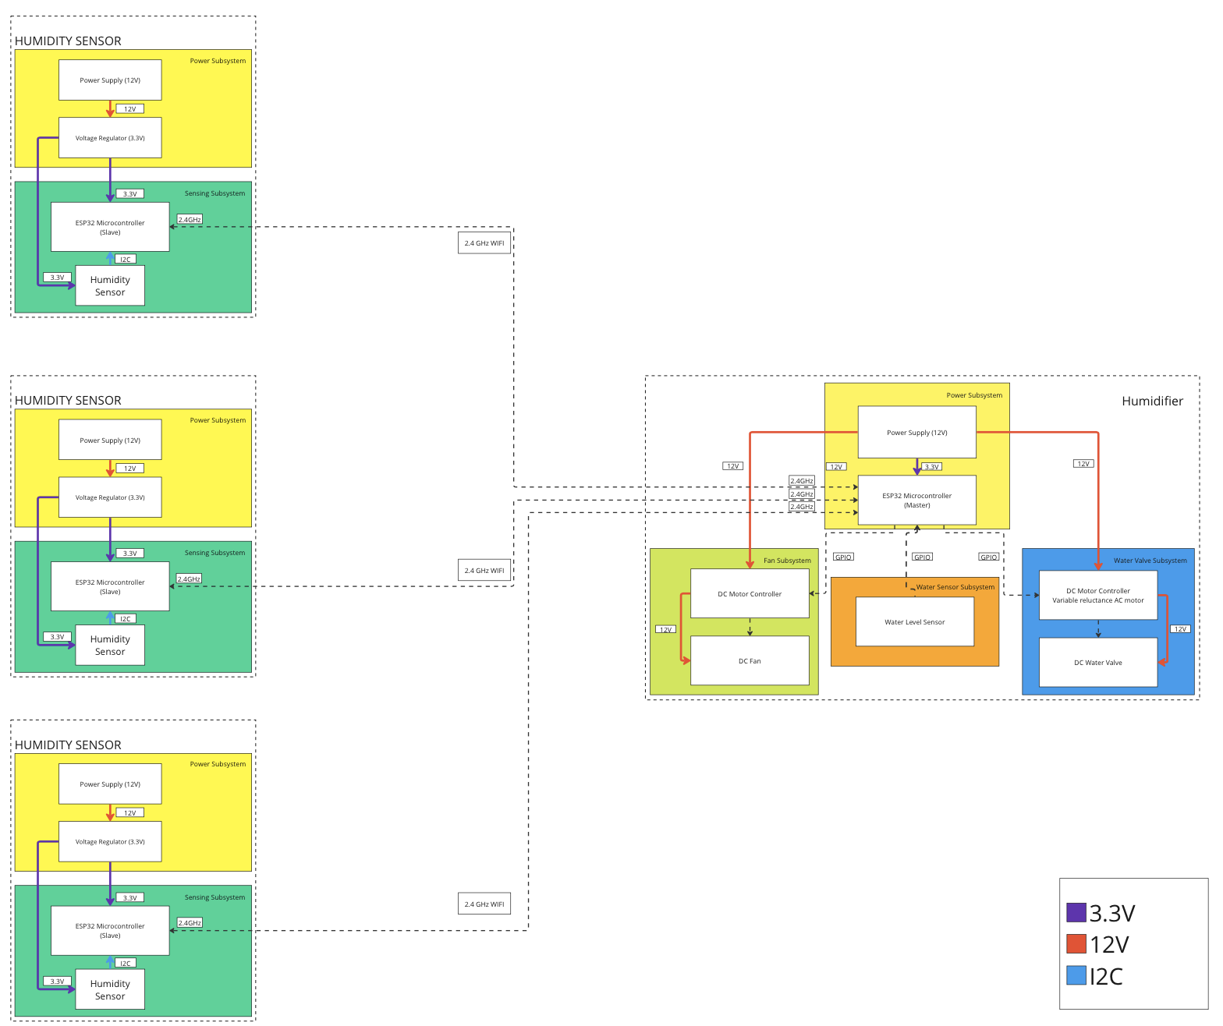

**Sunday, March 03, 2024**

**Objective: Work on PCB for sensor subsystem**

Today, I began working on the PCB schematic for the sensor subsystem. Yesterday, Woojin showed me his completed work on the Adafruit SHT45 development board. He showed me the output and proved that the ESP32 can communicate with the SHT45 and read data from it.

Because we want to make it to the first PCB order group (coming Tuesday), I will make a draft of the PCB schematic today.

The first thing that I did was find the ESP32-S3 microcontroller on our ESP32-S3 development board. Doing some research, I believe that it is the ESP32-S3-VROOM-1-N8. I downloaded the CAD file on Digikey, so that I can import it to KiCAD.

Next, I looked at the SHT45 sensor. I went on Sensirion’s website and looked through the documentation. They had a sample circuit. I think I will base my schematic on that, as the Adafruit development board has a lot of “fluff” on it. I also downloaded a CAD model on Digikey for the SHT45 sensor. I will be using the SHT45-AD1B-R3 sensor.

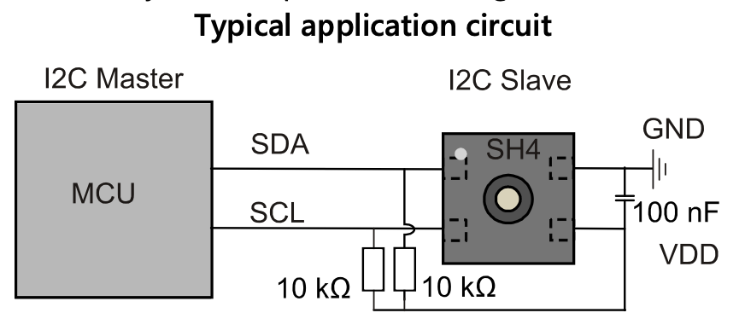

Aside from the two components mentioned above, we also need the power components. I will be using a fixed 3.3V voltage regulator that accepts up to 18V input. Looking through the documentation, I decided to choose the LDL1117S33R chip.

For the voltage input, I will be inputting 12V via a barrel jack to the PCB board. The input will be from a WSU 120-2000 AC/DC wall mount. The barrel jack will be a PJ-202AH jack.

We will also have decoupling capacitors throughout the circuit for the signals.

There are some issues with the voltage regulator on KiCAD. The reason is that there are two 3.3V output pins. It is not exactly passing the Inspection Test. If it still does not work, I will simply change to a different voltage regulator.

Aside from that, I still need to wire the BOOT and RESET buttons, as well as the USB bridge.

I found a good link from Espressif regarding wiring the ESP32. It has the USB-UART and USB-Bridge wiring too, as well as the buttons. It is the same ESP32-S3-Devkit-C board with the VROOM-1. I was going to do the USB-UART, but looking at the schematic, it looks like it has too many components, and is difficult. I will probably figure out how to program the USB-Bridge instead.

**Monday, March 4, 2024**

**Objective: Work on PCB and improve yesterday’s design**

Today, I will continue working on the PCB design. I will working on the micro-usb-b part.

Looking at the Espressif schematic, I can see that the micro usb provides a 5V connection. We will not be using the 5V, therefore, I will be omitting that. I am following the Espressif schematic below to do most of the PCB schematic. I hope to use the same parts also, even though they may be from China.

I am getting some errors for the ESP32 footprint. There are some through-holes in the middle of the chip. Talking to Peter, a friend from ECE395, he says that they are for heat dissipation. I can ignore it or remove the holes in the footprint editor. For the first revision of this board, I will remove it. This is the prevent extra costs. I will talk to Jason about the holes.

I have finished the prototype. I have submitted the board to PCB-Way, and it passed all tests and is ready for production.

**Tuesday, March 5, 2024**

**Objective: Turn in PCB design, meet Surya.**

Early today, I finished the schematic and PCB layout. I will review it with Jalen this afternoon before we email the file to Surya.

During the meeting with Jalen, we did not find any issues with the schematic. Everything looks ok.

I have sent the email to Surya.

In the meeting with Surya, we also told him our plan for Spring Break. We hope to finish the humidifier subsystem’s PCB over Spring Break. Surya says he is quite happy with our progress on our PCB when compared to the other groups.

Order some parts for PCB, primarily BJT and Diode from China. It will take two weeks to arrive, so it will arrive on time after Spring Break.

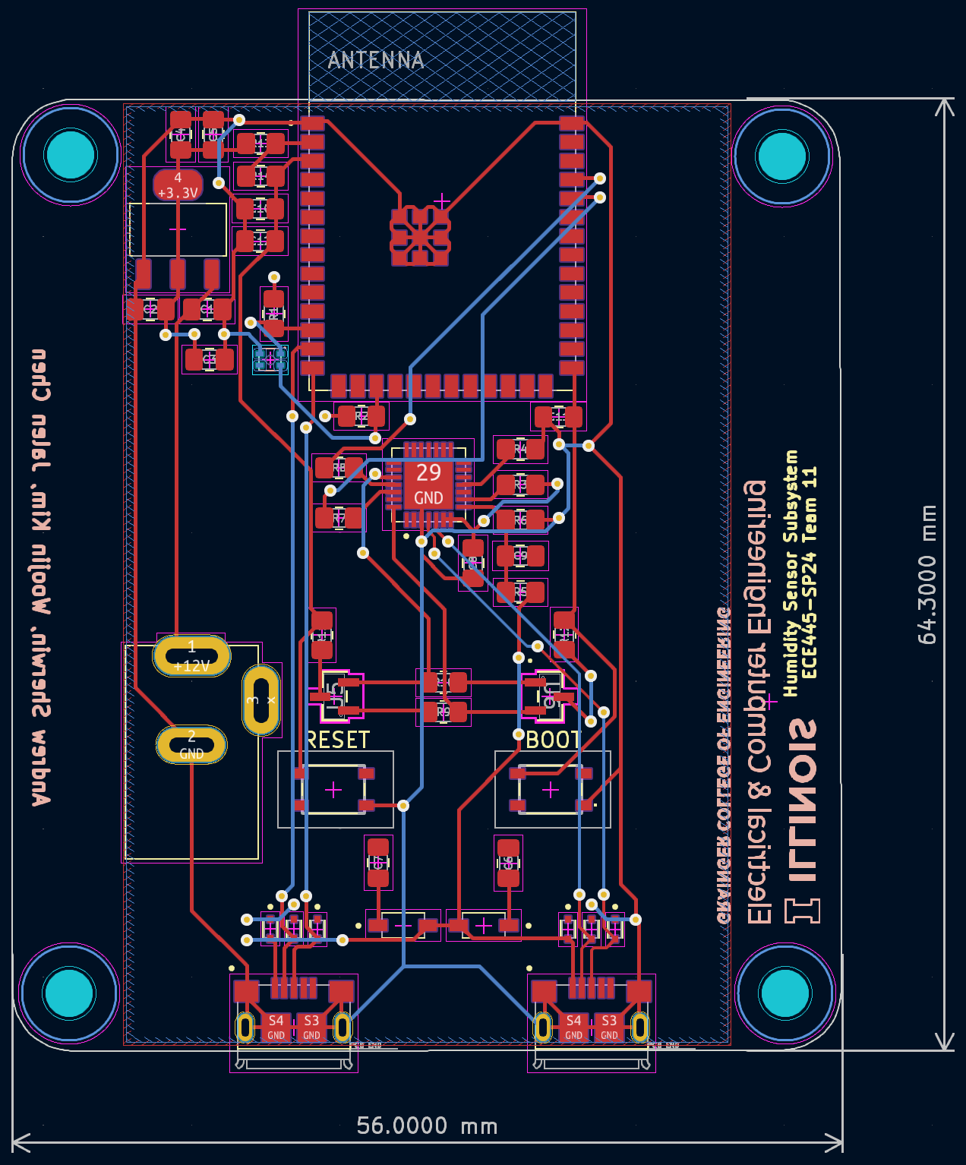

**Monday, March 18, 2024**

**Objective: Work on Humidifier PCB, talk to Jalen**

Today, I am working with Jalen on the humidifier PCB. We have previous communicated on what needs to be done. Right now, my first problem is converting my KiCAD 8.0 file t0 KiCAD 7.0. The reason is because KiCAD 8.0 is less than a month old, and it has a lot of bugs.

I tried finding ways to directly convert the files, and it seems like it is not possible. Also, the symbol and footprint library has already been converted to KiCAD 8.0 version. So, I will have to re-import all the symbols and footprints again. This will be a bit tedious. I think I will have to redraw the schematic and PCB again.

After redrawing the circuit from the sensor subsystem, I fixed any errors.

Next, I helped Jalen with the relay. He said that we needed an optocoupler. This is used to prevent noise. I did some research and decided “why not”. It was a bit difficult finding parts for the optocoupler, as we were not sure what to look for. Furthermore, most of the parts on Digikey that we clicked on did not have EDA files. I ended up going to SnapEDA and searching for optocoupler and clicking the first item. The first was the VOM617AT. The specs looked ok, and it had a stock of over 6000 on Digikey, so it must be decent. I suggested it to Jalen. He thinks we should try it out.

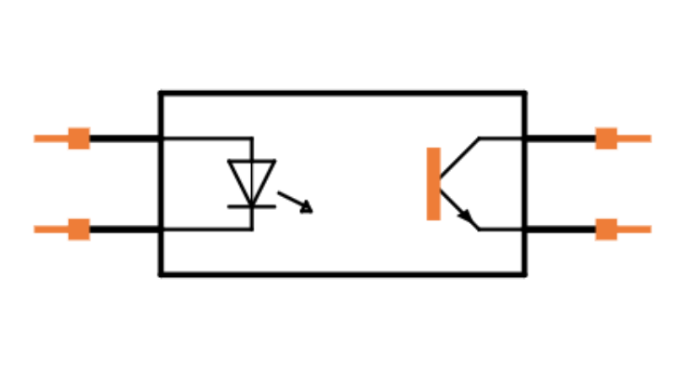

After more discussion, it seems like Jalen’s initial understanding of what the relay does was flawed. He thought that the relay also provided power for the ESP32. However, it is the ESP32 that powers the relay. The 120V on the end of the relay does not go to the low power side.

We will be using a premade transformer to power the ESP32. We decided that it was not worth the time and trouble to make one. We will be using the EPS-15-12 120V AC to 12V DC transformer. I will also connect the DC end to a barrel jack for the PCB.

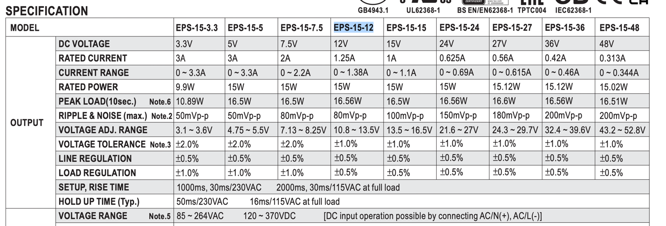

Order some more parts from Digikey for the humidifier PCB. Total was around $67.00.

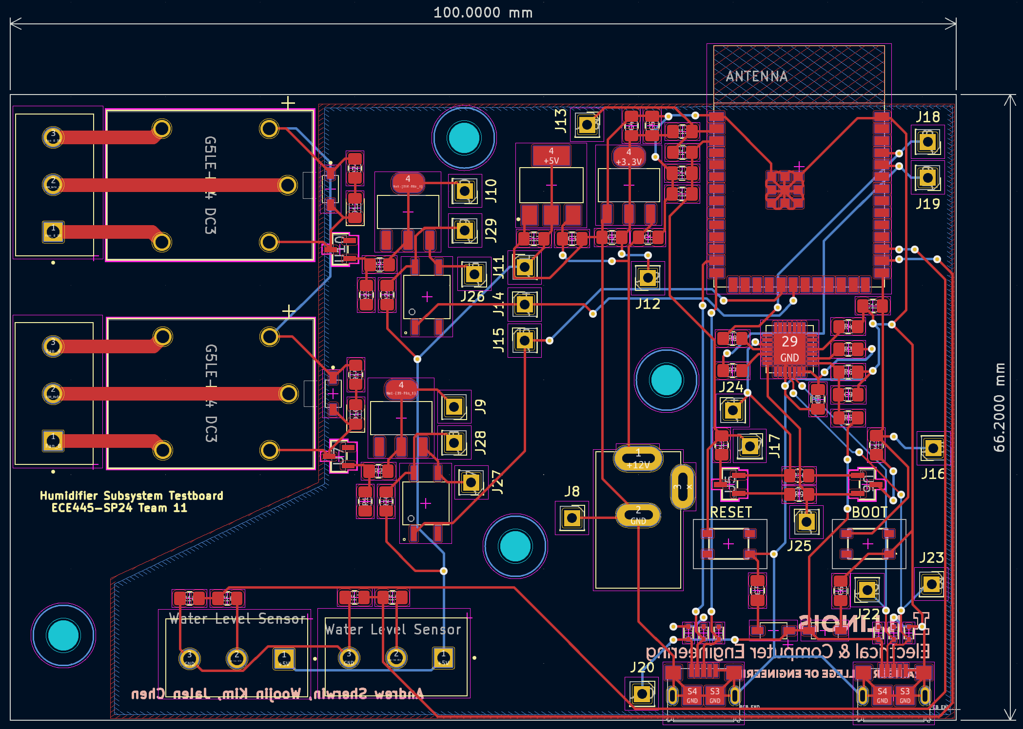

**Tuesday, March 19, 2024**

**Objective: Work on humidifier PCB, turn in PCB, meet Surya, discuss water valve**

Today, when talking to Jalen about the water valve, we discovered that our water valve might not work for the demonstration. The problem is that the water valve requires a minimum pressure for it to activate. It does not work by gravitational water pressure. We will have to find a different valve that has no pressure rating.

We found a new valve on Amazon that require little to no pressure to work. The downside is that this controller uses quick connect. Also, we don’t know how much pressure will be during the demo.

This new valve requires 12V DC to power. Originally, we were going to use some kind of motor controller to control it. However, it occurred to me that the relay could use 12V DC. This will be perfect for the ESP32 sending 3.3V activation signal, activating the switch, and sending 12V to the motor.

The only uncertain thing is how does the valve close. Looking at the description, it seems like the valve will close on its own. We will try it out later.

When meeting with Surya today, we told him about our progress. He told us that we should start talking to the machine shop. I told him that I will do it this week. He says that the machine shop should be working on our parts now. However, he is still happy that we are making good progress compared to the other teams.

I told Jalen to help create a spreadsheet of the parts that we have ordered and the parts that we need to still order. The spreadsheet should have a total of parts needed for each PCB. Also, the list should have vendor links of where the parts are from.

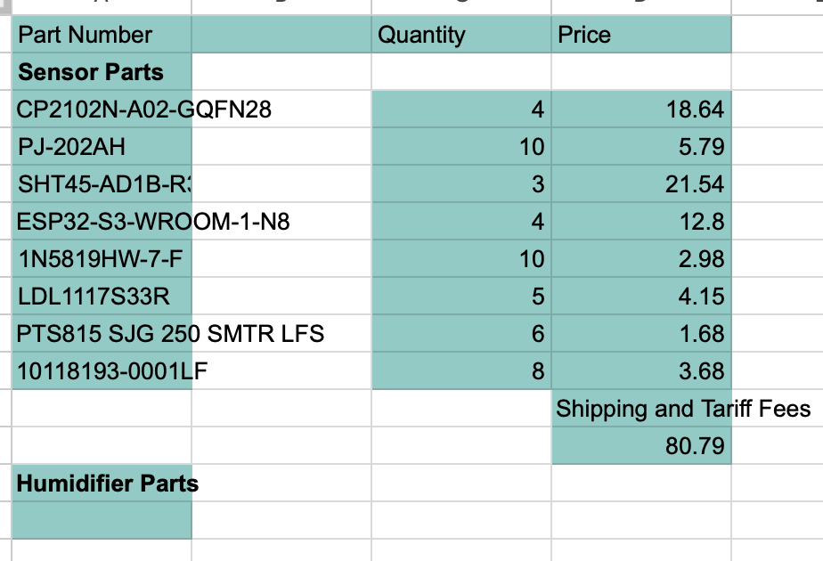

I updated the block diagram once more. This time, the block diagram has electrical relays instead of the motor controller. This is because I think the design will be more modular. When changing this, I also updated the GPIO lines. The idea behind the relays is when the switch is activated, the circuit for the water valve and the humidifier will be complete. As a result, they turn on.

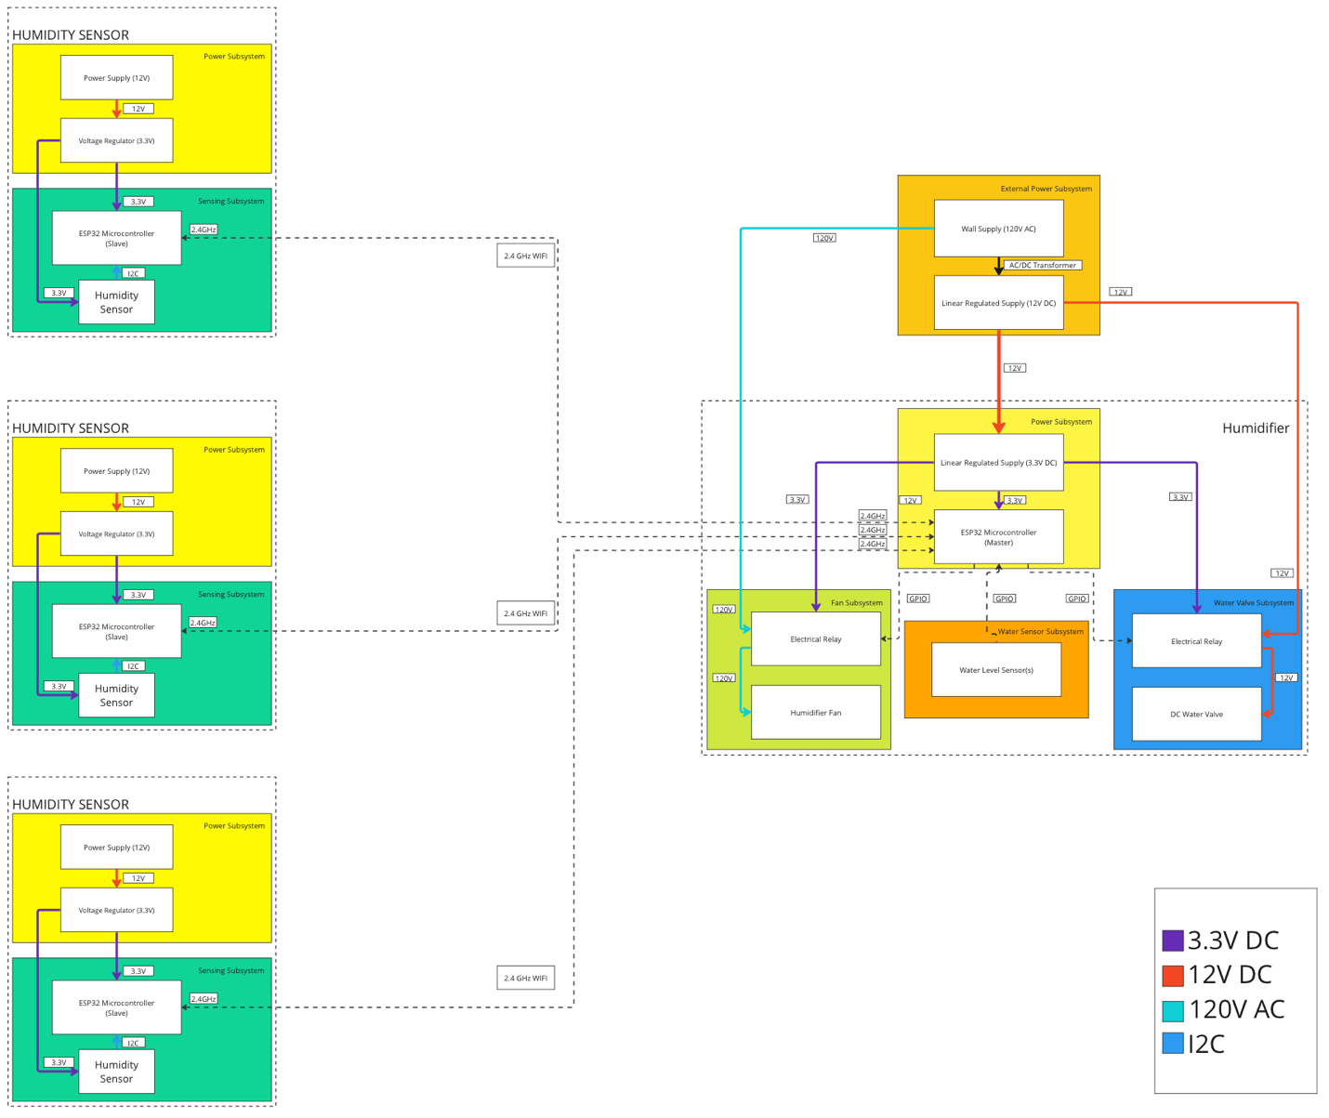

**Thursday, March 21, 2024**

**Objective: Talk to machine shop**

Today, I brought the humidifier and PCB parts to the machine shop. I also drew some diagrams to show the machine shop what needs to be done.

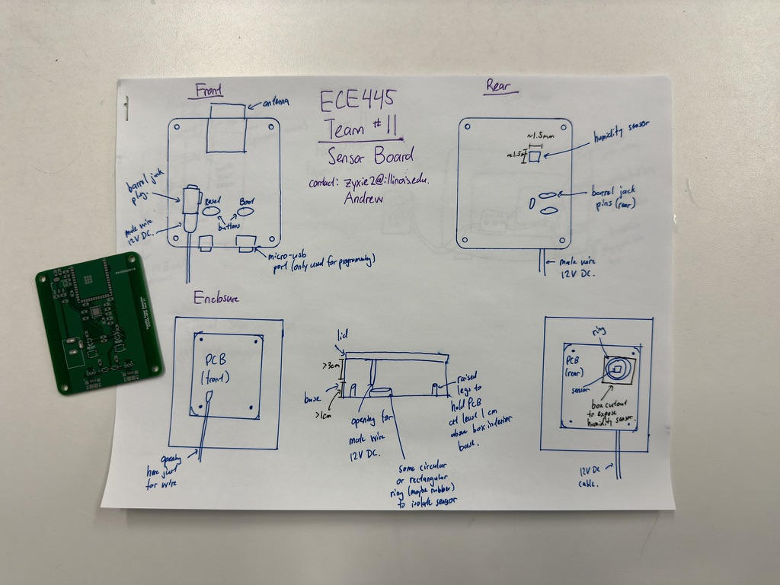

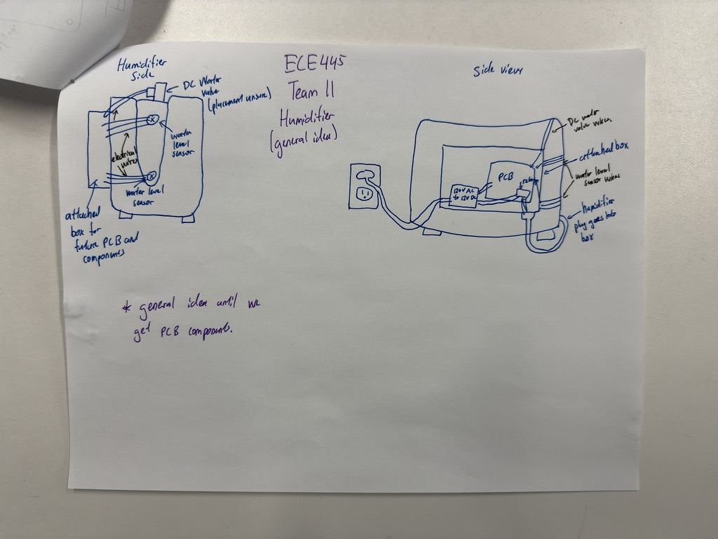

I think that Gregg understands the idea. However, because we are still waiting for parts, he cannot begin working on it yet. Gregg requested that I give him a sample of our PCB and the water valve. He says he will be on vacation for a week starting the coming Monday. I told him I will get it to him tomorrow, as the valve is arriving tomorrow.

Jalen and I continued to work on the parts list. Below is the updated list. It consists of parts for the sensor and the humidifier subsystem:

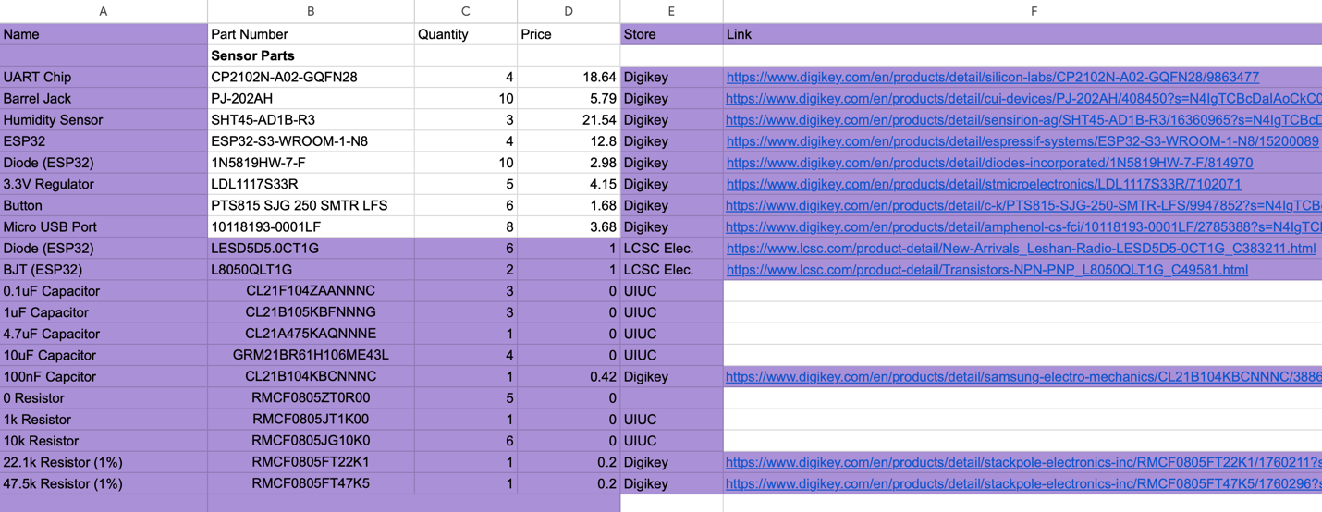

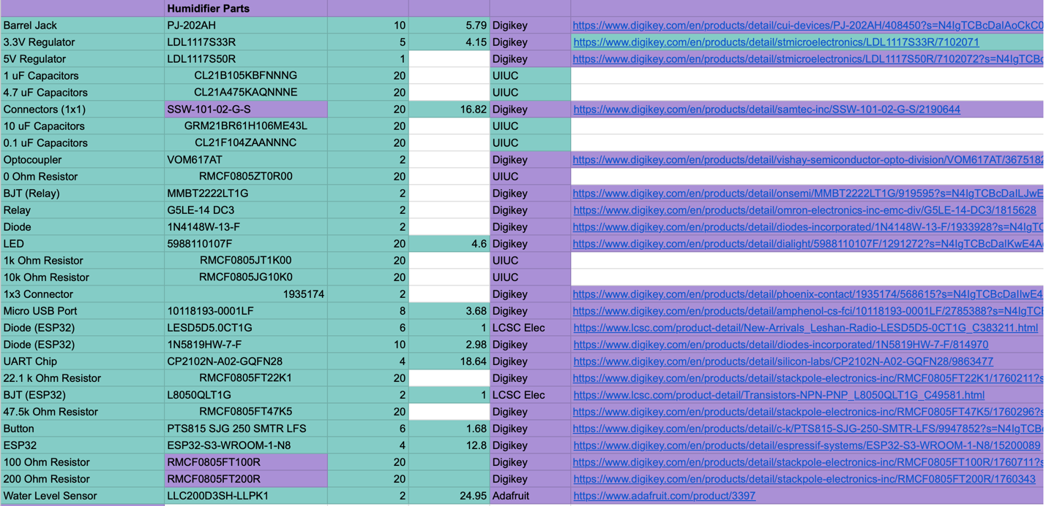

**Friday, March 22, 2024**

**Objective: Parts did not arrive**

The valve did not arrive today yet. I think some motherfucker stole my package. I went to see Gregg to report the bad news, and apparently, he had already left for his vacation!?

**Sunday, March 24, 2024**

**Objective: Woojin got ESP32s to send data**

Today, Woojin announced that he got the communication between two ESP32s to work. The original plan was to control the LED of one ESP32 from another ESP32 over 2.4GHz Wi-Fi. However, Woojin went above and beyond by being able to send the SHT45’s data to another ESP32 and being able to read it.

**Monday, March 25, 2024**

**Objective: Order parts from funding**

Order parts for humidifier subsystem. I think that this will be the last order from the $150.00 budget that we have. This order is mainly UART chips and plugs for the transformer that we missed.

**Tuesday, March 26, 2024**

**Objective: Meet Surya, test water valve**

Today, the water valve arrived. I tried to test it. However, initially, I was confused on how it works. I can hear it clicking, but looking in the hole, I did not see the valve opening. As a result, I took it apart and found the below:

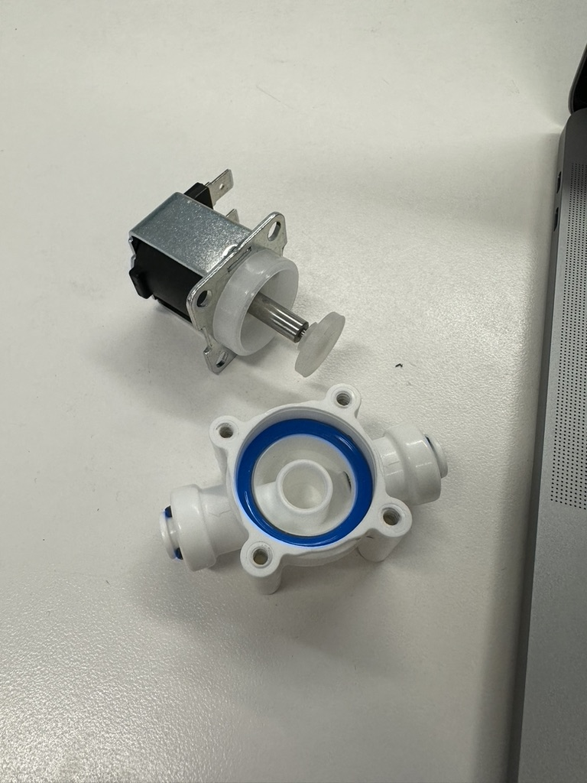

As seen in the picture, this is not really a valve, but a plunger. It works with a coil. When there is a current through the coil, a magnetic field will be created and the valve will be sucked upwards, thus opening the valve. The valve is normally closed when there is no current going to it. The manufacture’s specification says that it draws around 4.8W. This means that there is 0.4 amps flowing through it.

$$4.8W=I*12V$$

$$I=0.2A$$

This should be enough for our applications. The only worry is that the seal might not be great. However, since our real valve will not be like this, as this is an “unpressured valve”, it will not be a real problem.

We met with Surya; I told him to good news about Woojin getting the sensors to send data over Wi-Fi. Surya tells us to contact the machine shop to see how progress is. Surprisingly, we still have around $30 of budget left. We may use it to order our second water level sensor.

**Wednesday, March 27, 2024**

**Objective: Order parts for humidifier, determine power input for humidifier subsystem**

Today I had to order some parts for the humidifier subsystem. I had to figure out a way to power the PCB, and I thought that the best way would be to use a switching regulator. I thought about making our own power supply, however, with the limited cost and time, I think it would be too difficult. Also, it is highly unlikely that we can build one for cheaper than buying one at around $6.00. Furthermore, the pre-built ones have surge protection built in, and this is important for voltage spikes. We will not be sure if our own design can protect against this, and it is too risky frying all the other components.

We only need a 12V input in our humidifier subsystem. As a result, over multiple hours of research, I decided on the ESP-15-12 AC/DC converter. This can provide a 12V DC output with a 1.25A current output. I estimate that this should be enough for the PCB and the water valve. Looking at the diagram below, I will also need to buy some plugs for the input and output.

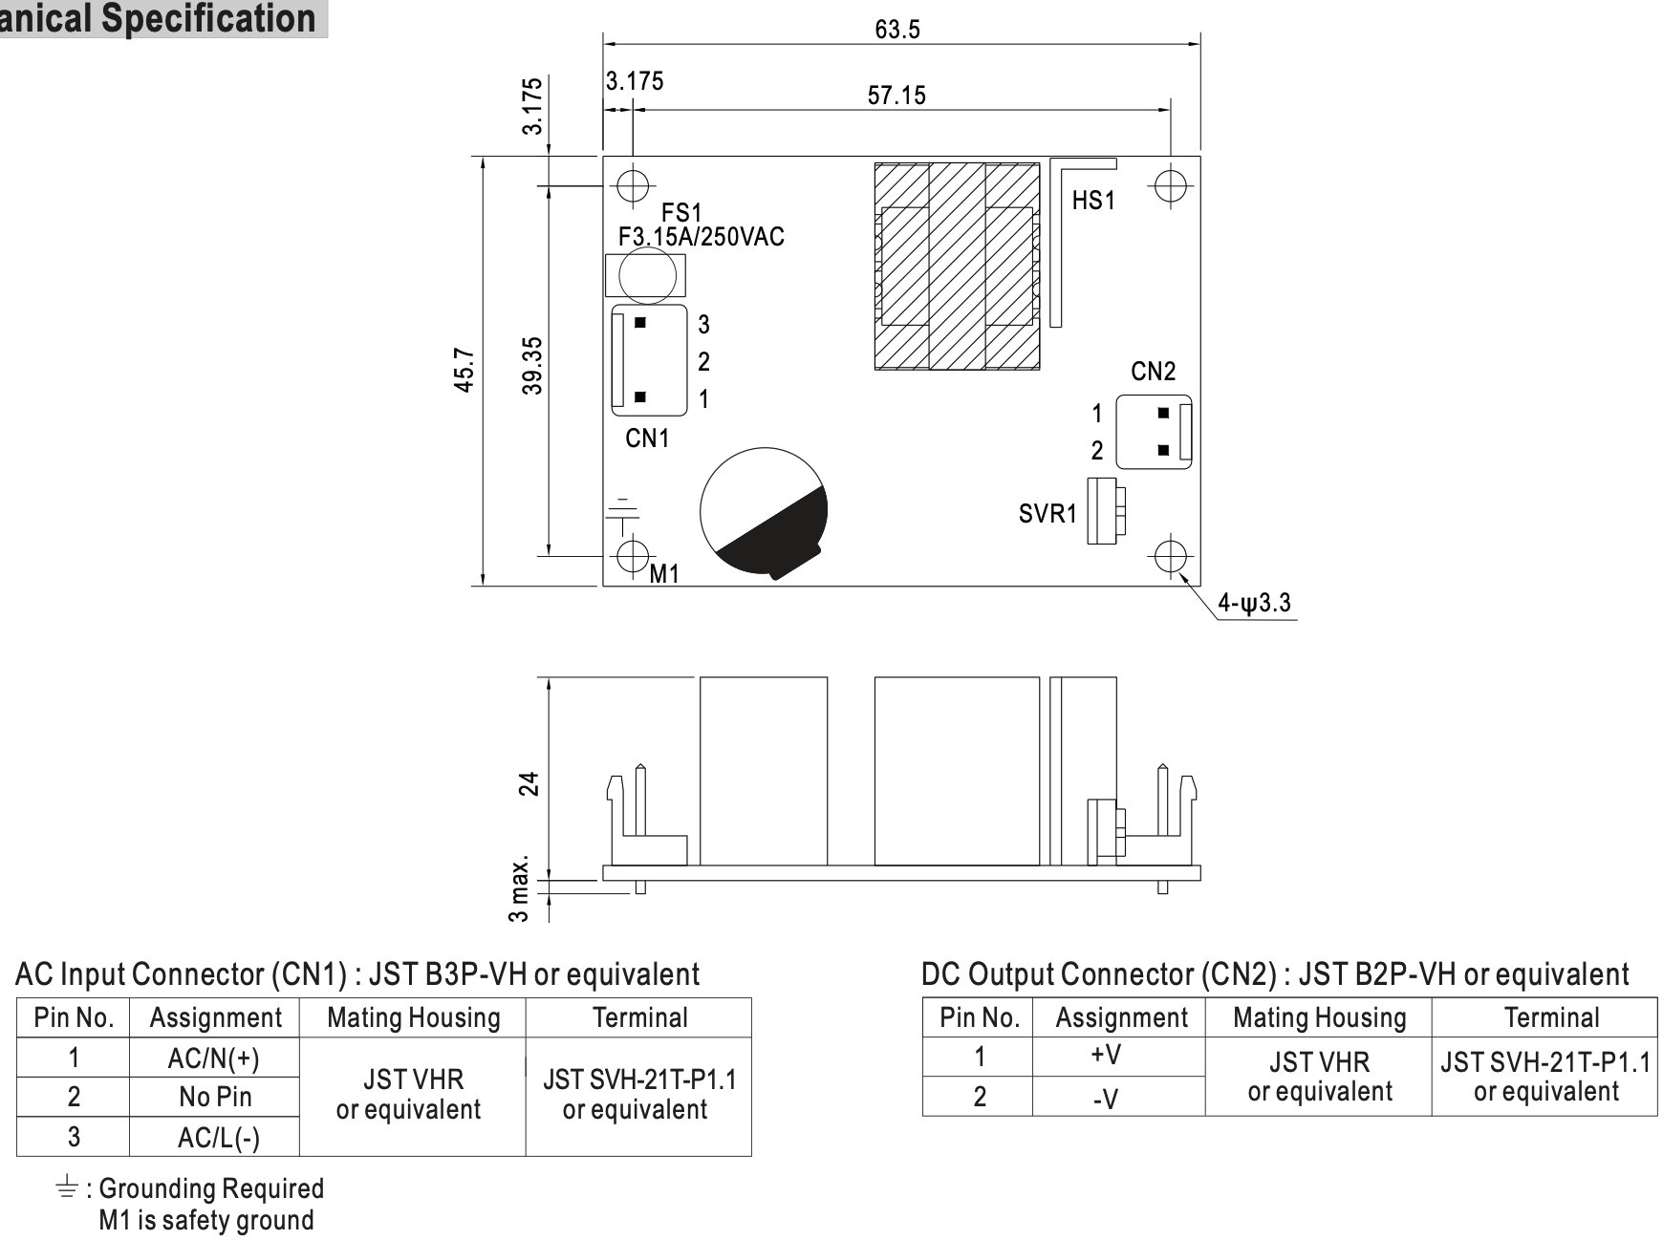

I was able to find some suggested ones on Digikey with a crimp connection. I hope that this will work.

Aside from that, I also must think about a way to send the 120V AC into the subsystem, and a way to power the humidifier. I did not want to make any difficult changes to the humidifier’s fan. As a result, I came up with the idea below:

There would be a box. There will be an input power into the box through a wire. This wire can be unplugged anytime. This leads to the portability of the box. There will be a the 12V AC/DC converter in the box. This converter will go feed the PCB and other components.

Along with the AC/DC converter, I bought a couple varying parts for the idea above. This was in Digikey order: 860944423.

Aside from that, I also ordered a relay development board from Digikey. This was part number 1528-1738-ND. I wanted Woojin to start working on developing the GPIO functionality as soon as possible.

Finally, we paid for 2 day shipping on the order, so that it can get here by the weekend.

We also used our remaining budget by ordering another Optomax Digital Liquid Level Sensor. This will use up all our remaining budget.

**Friday, March 29, 2024**

**Objective: Solder relay dev-board**

Today, the parts and the relay arrived. I could not really do anything with the parts, as the machine shop still needs to work on the project. We will need to talk to them soon. The development board for the PCB seems pretty compact, so our PCB will also be compact.

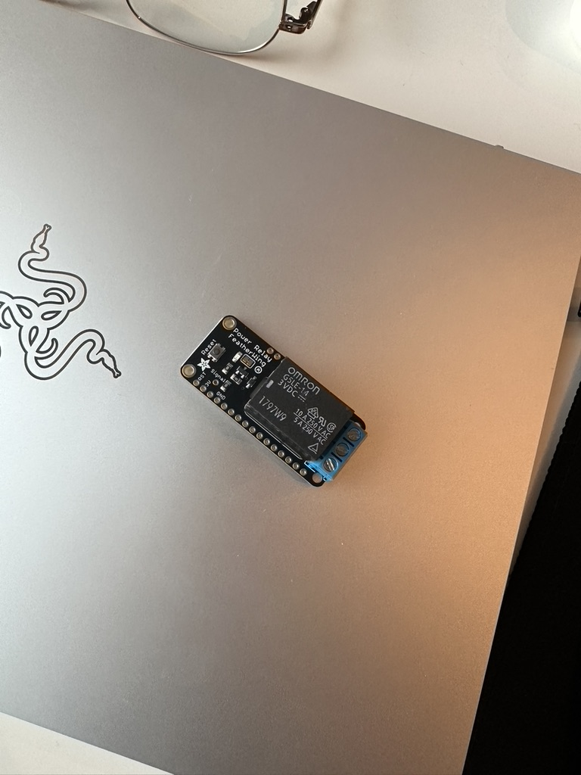

**Saturday, March 30, 2024**

**Objective: Solder PCB for sensor subsystem**

Today, Jalen and I started soldering the humidity sensor PCB. However, we discovered that we were still missing some SMD components from the ECE Electronics Supply Shop. I immediately sent an email to Surya so that we can get some. However, since we were already at ECEB, Jalen and I laid the paste and soldered with the parts we have on hand. We took a while, as I was teaching Jalen how to lay the parts on the PCB. But we were finished.

The ESP32 was a little bit hard to solder. The ground pads were hard to heat up. Maybe the iron was not powerful enough. We will finish soldering in another day when the parts arrive.

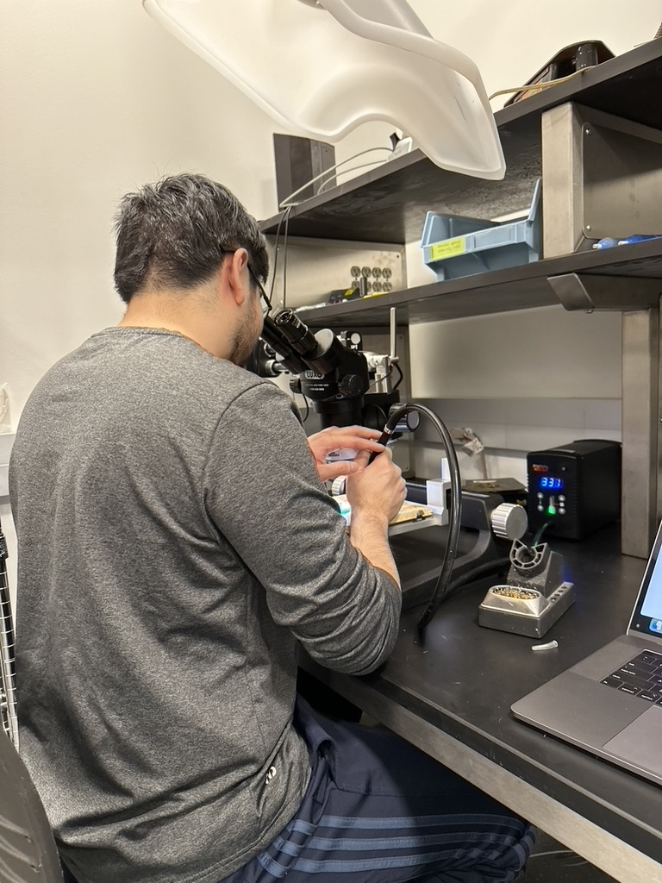

**Monday, April 1, 2024**

Jalen and I update the parts list one more time. This time, we color coded where parts are from and did final adjustments to the quantity.

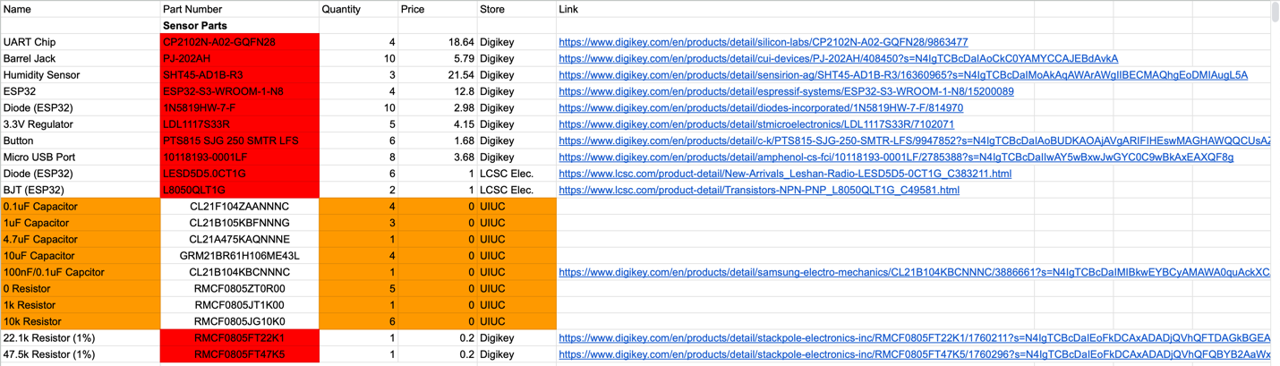

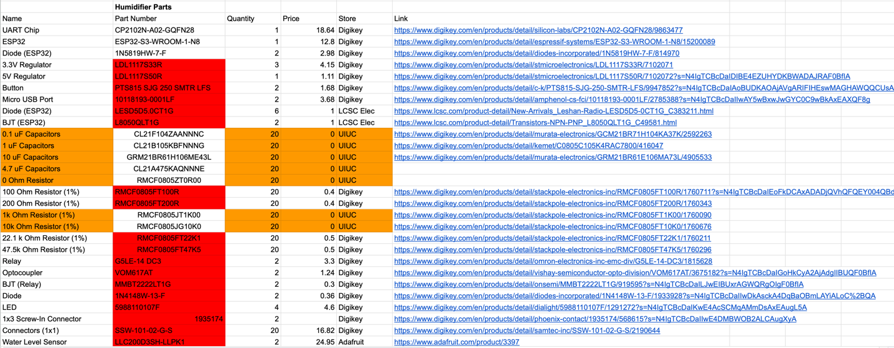

**Tuesday, April 2, 2024**

**Objective: Meet Surya, show Surya our PCB, address issues with PCB**

Meeting with Surya today, we told him that we will be working on our PCB ASAP since parts are here. Surya also asked us to check in with the machine shop, and we told him that the machine shop is working on our parts, but there is delay. However, the machine shop did tell us to not worry.

Tonight, Jalen and I worked on soldering the rest of the first sensor subsystem PCB. It turned out to be a bad idea to not do all the soldering at once, as we had to remove all the old solder off the pads before laying new paste.

After fixing some bridging in certain parts of the chip, we were able to plug the PCB into our 12V wall power supply. This 12V was from my previous class in Fall 2023. We were able to program a basic program to the ESP32.

However, when I tried to program a sample Wi-Fi access point code to the ESP32, the ESP32 initially worked then started crashing. The symptom is that, on the serial monitor, it would show that it was connecting and disconnecting. Also, the voltage regulator and the surrounding capacitors got really hot. In fact, it got so hot that it was uncomfortable to the touch. Ultimately, the voltage regulator fried itself and stopped outputting 3.3V. Thankfully, it output 1.5V, so it did not fry the ESP32.

We think that the regulator might be defective, so we changed it for another one. Though the new one did not fry itself, it still had the issue where the ESP32 would keep connecting and disconnecting.

It was 3-4am, so we decided to go home and solve it the next day.

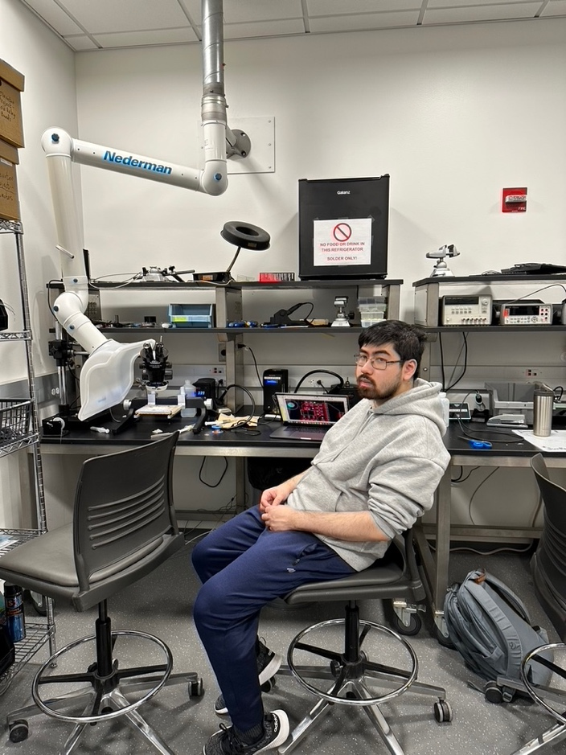

**Wednesday, April 3, 2024**

**Objective: Debug PCB, why it is constantly restarting**

I started a Reddit post on r/ESP32 to ask why I was experiencing this problem.

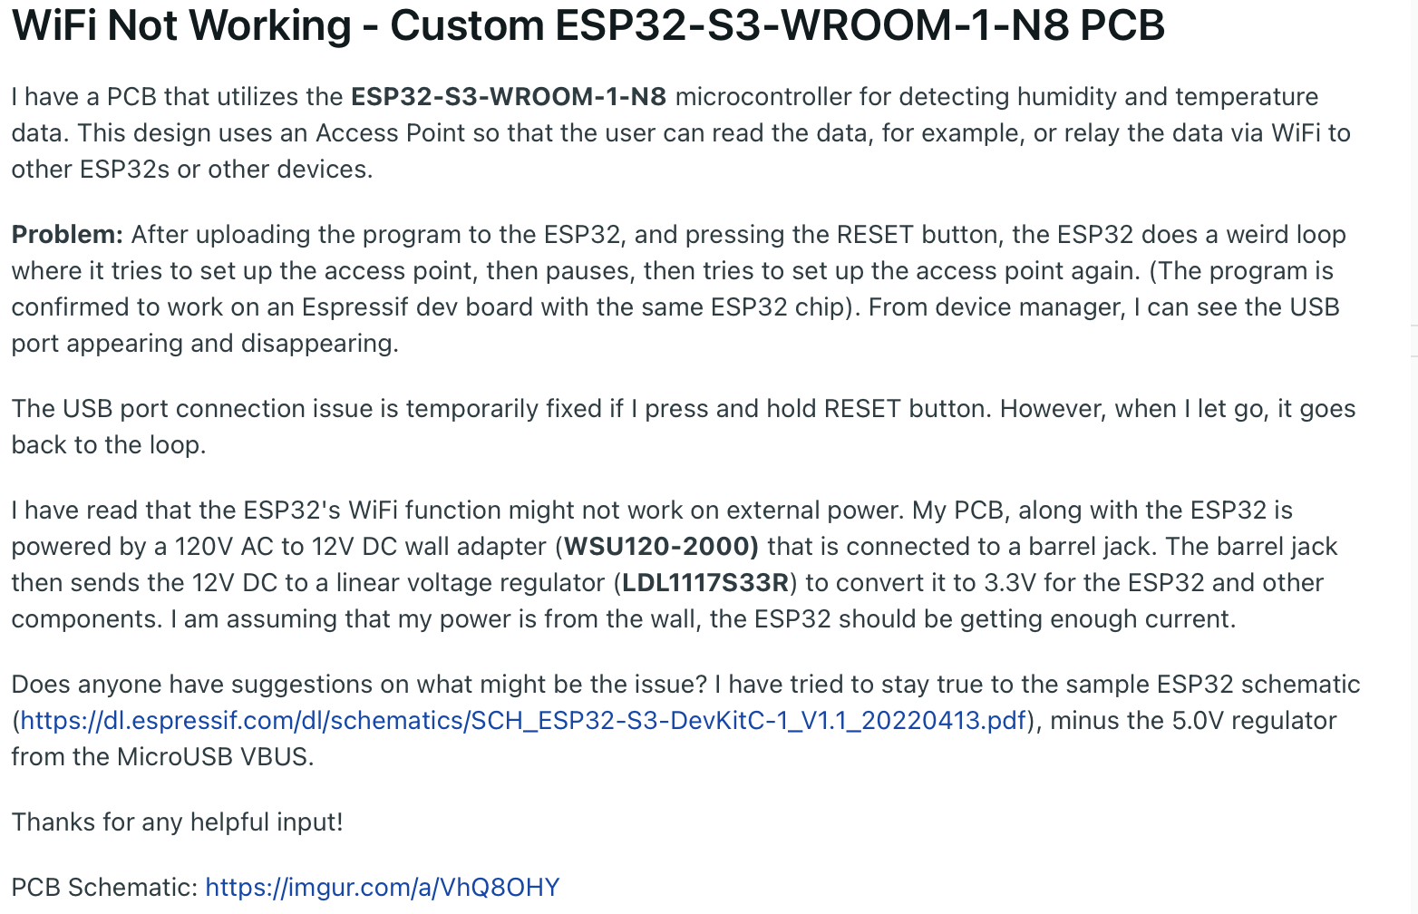

I did some research on why this might be. There are similar symptoms online. It seems like the reason for this is because the Wi-Fi module on the ESP32 draws a lot of current. As a result, the power draw through the voltage regulator is high. Maybe with a better power supply, the ESP32 will not “throttle”.

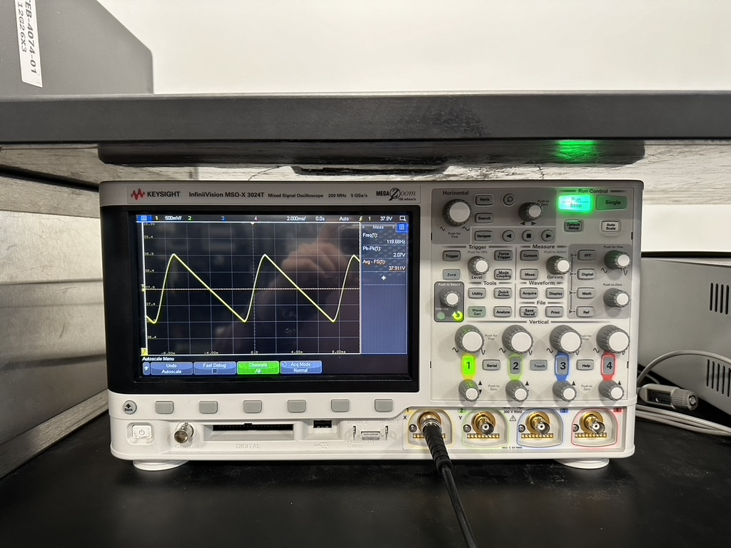

A Reddit user suggested using the power supply from the lab bench and using a lower voltage. The reason is with a high voltage difference in the input and output of the linear voltage regulator, the difference is dissipated as heat.

As a result, I first tested the bench power supply at 12V. It still had the throttling issue, even though enough current was supplied. Next, I started decreasing the voltage by 1V increments. I noticed that starting at 8.0V and below, the ESP32 would no longer throttle. This means that we should figure out a way to decrease the voltage supply.

I talked to Stephen Messing, a PhD student from the Laser Optics Physics Laboratory research group (Andrey Mironov and Gary Eden), and he suggested putting linear voltage regulators in series, with increment decreases in voltage. This will decrease the voltage drop and balance out the power draw through each regulator.

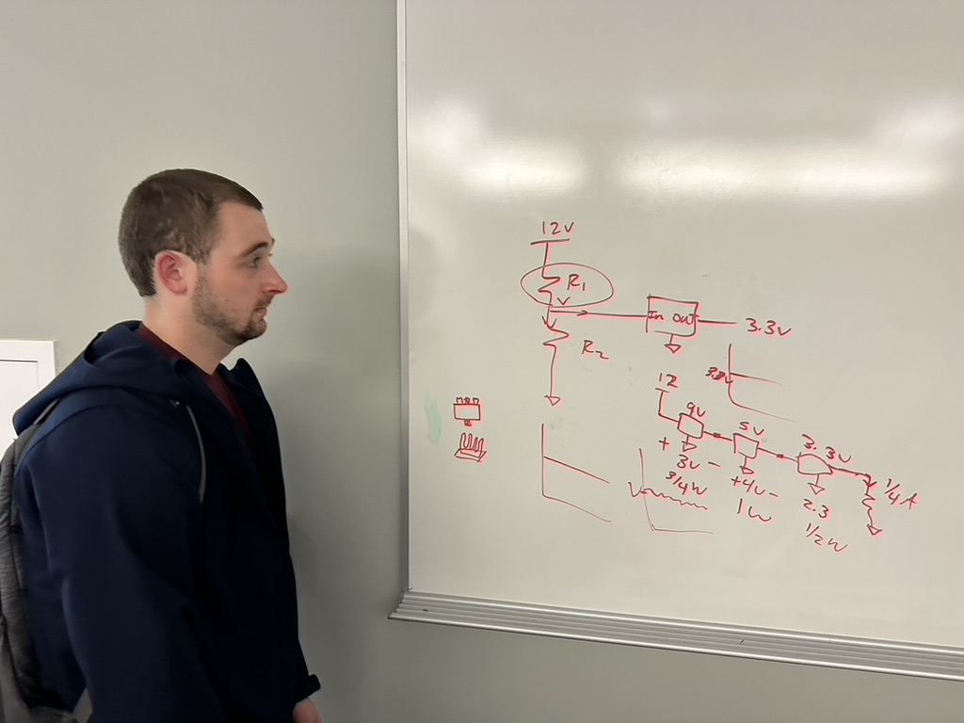

Ultimately, I decided to use a 5V wall plug the power the sensor subsystem, and a RS-15-5 AC/DC converter to power the humidifier subsystem’s PCB. I also bought a new AC/DC converter. Instead of the previous one, this one has an isolation case. Also, the inputs and outputs are screws. This makes it easier to wire.

**Thursday, April 4, 2024**

**Objective: Draw diagram so Woojin can understand, solder humidifier subsystem PCB**

In ECE343’s lab, I drew this diagram detailing the idea behind the humidifier subsystem.

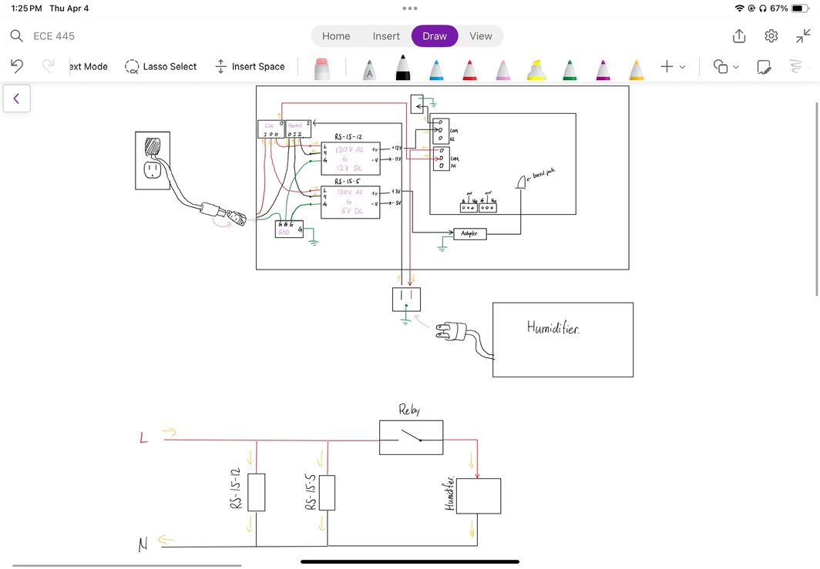

The diagram above shows the inputs and how the different components will be powered. I hope that this will help Woojin understand how everything goes together better.

Later that night, I took the burden upon myself to solder the PCB for the humidifier subsystem. Jalen said he can help on Saturday, but that is already too late. This is because I may need to order parts on Friday.

**Friday, April 5, 2024**

**Objective: Solder PCB for humidifier subsystem, debug PCB**

I finished the PCB early Friday morning. I just soldered one relay and one water level sensor input.

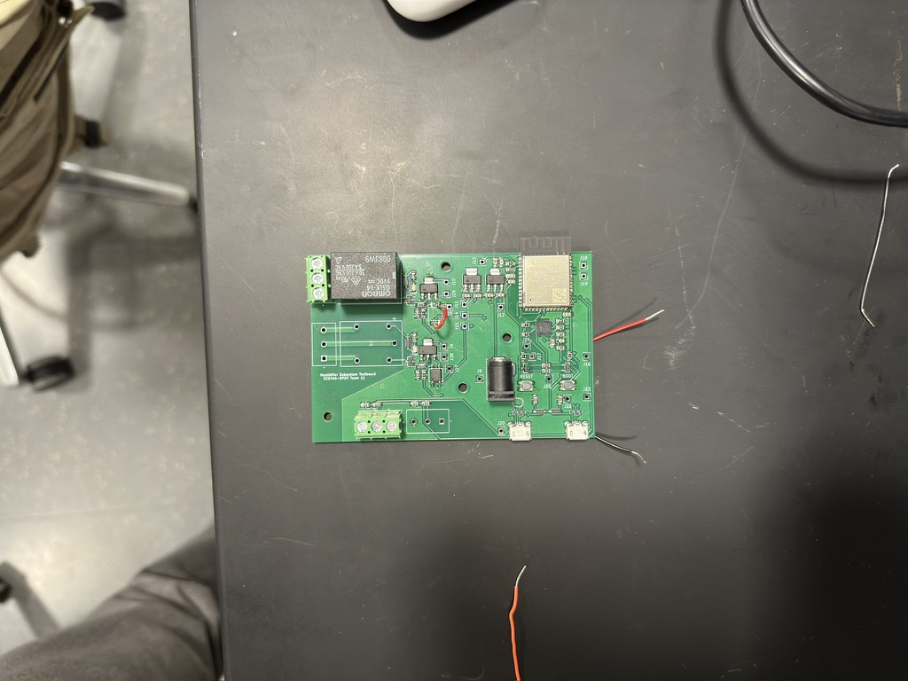

When I programmed it, the PCB works with Wi-Fi with a 5V input. However, GPIO 19 and 20 were not outputting signals to the relays. I think that the ESP32 was not soldered on properly. So, I tried to remove the ESP32. I think I heated the board too hot because there was smoke. Also, upon inspection, the UART chip had a hole in it and the push buttons were disintegrated. At 5:40am, I gave up and decided to go home.

When I got home, I also worked on ordering new parts. I ordered a couple more ESP32s, relays, UART chips, and other various parts that can be used on the sensor and humidifier subsystems. This is so that we don’t need to wait for parts if we need any.

At night, I went to Home Depot with Taiyuan (Daniel) Hu to get some parts. I got some 14 gauge Romex wires, 5 input WAGO connectors, 2 input WAGO connectors, Klein no-contact voltage tester and IR thermometer, and a Milwaukee wire stripper and crimper.

**Sunday, April 7, 2024**

**Objective: Make revisions for humidifier PCB, improve design on final round**

Today, I worked on some PCB revisions to the humidifier PCB. Because Tuesday, April 9, 2024, is the fifth round of PCB orders, we needed a fail-safe for our humidifier subsystem. I made 5 PCBs. The first order is another order of our, already working, sensor subsystem. The next is an order of our humidifier subsystem from the second round. The third board is the same, but with the GPIOs for the relays moved. The fourth board is a re-routing of the traces in the third board. The fifth board contains cutouts for the high voltage. I spent the whole night doing this and finished early in the morning.

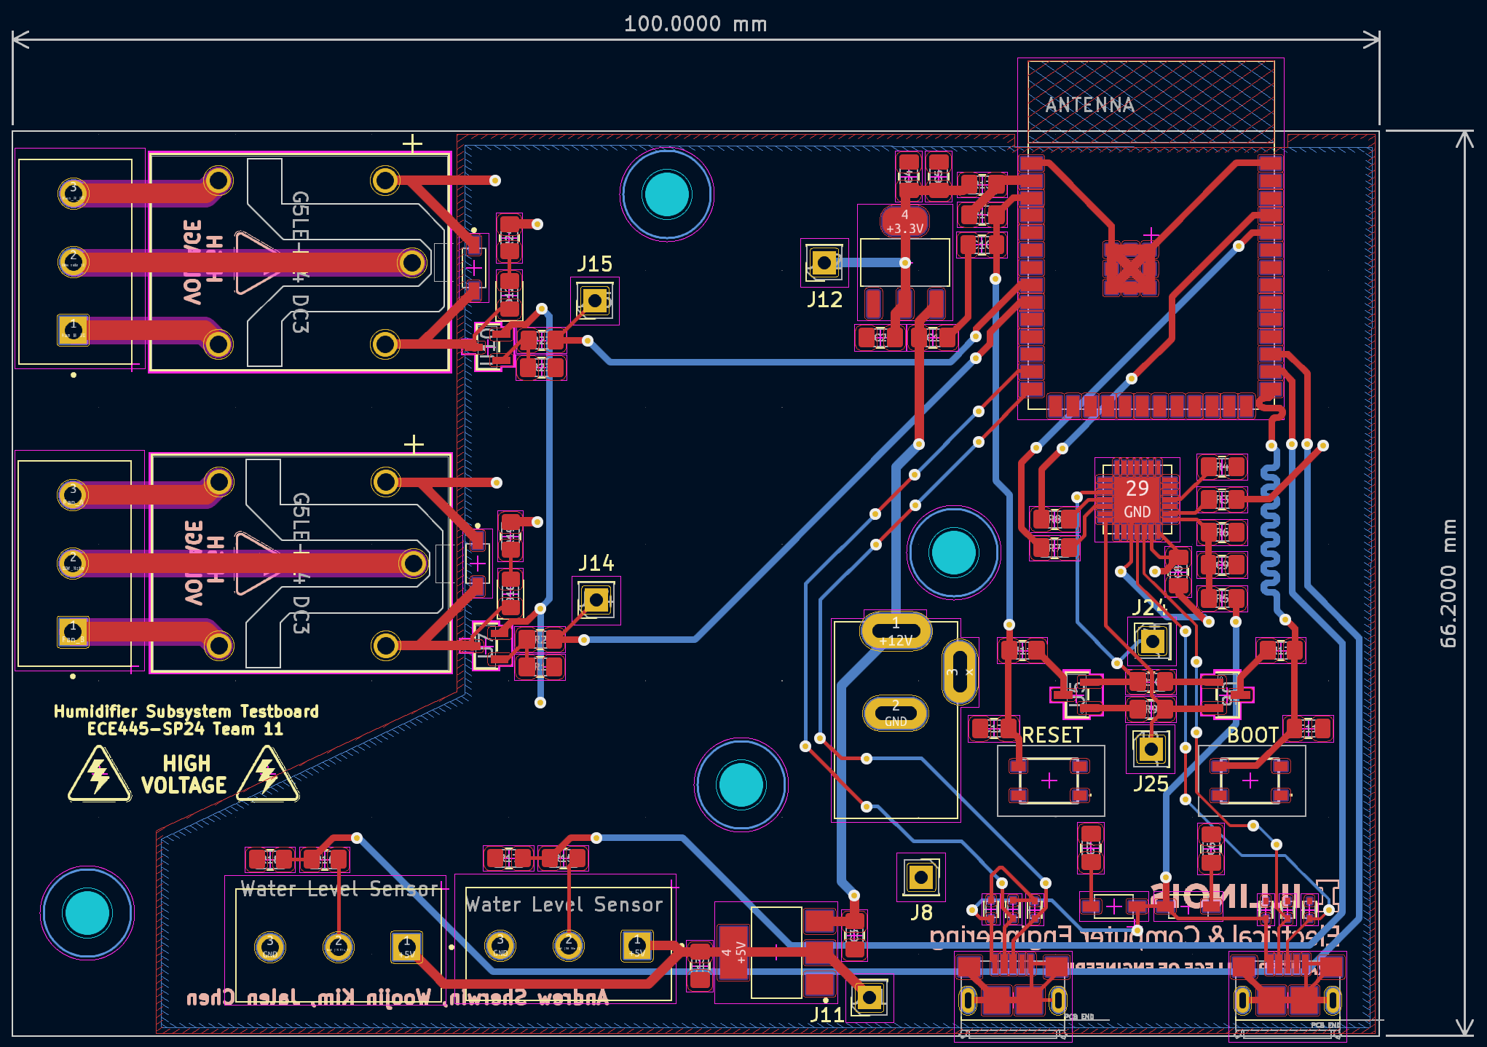

**Monday, April 8, 2024**

**Objective: Talk to machine shop about our project**

Today, I talked with the machine shop. I needed to talk to Gregg about our project, as he sent us an email saying he came back from vacation.

When I went in to talk to Gregg, it turns out that he was involved in a car accident in the morning of March 22, 2024. As a result, he was not able to come back to ECEB. He had a scar on his upper right eyebrow. I went over the project with him, and he said I should get a call in the next few days to the end of the week.

**Wednesday April 10, 2024**

**Objective: Meet Surya, talk to him about machine shop, solder remaining PCBs**

Today we met with Surya. Surya asked how the PCBs were going, and I told him that we are working on it. After the meeting, Woojin and I decided to solder the remaining two sensor subsystem boards. I taught Woojin how to place the components and paste the board with the stencil.

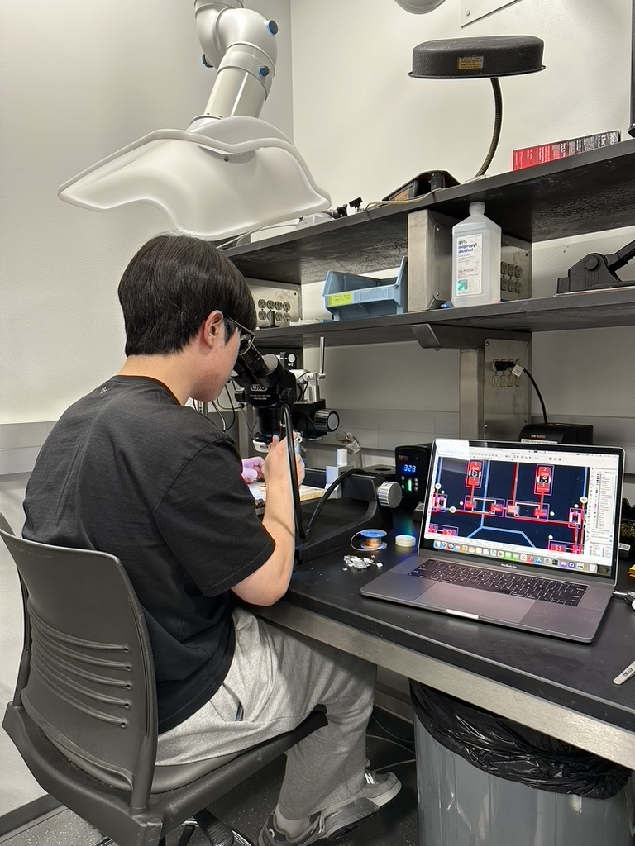

I did the ESP32 chip, as Woojin does not have experience to do it, and I don’t want him to mess up. We finished early Thursday morning. We tested the boards with the programs, and they all work on the first try.

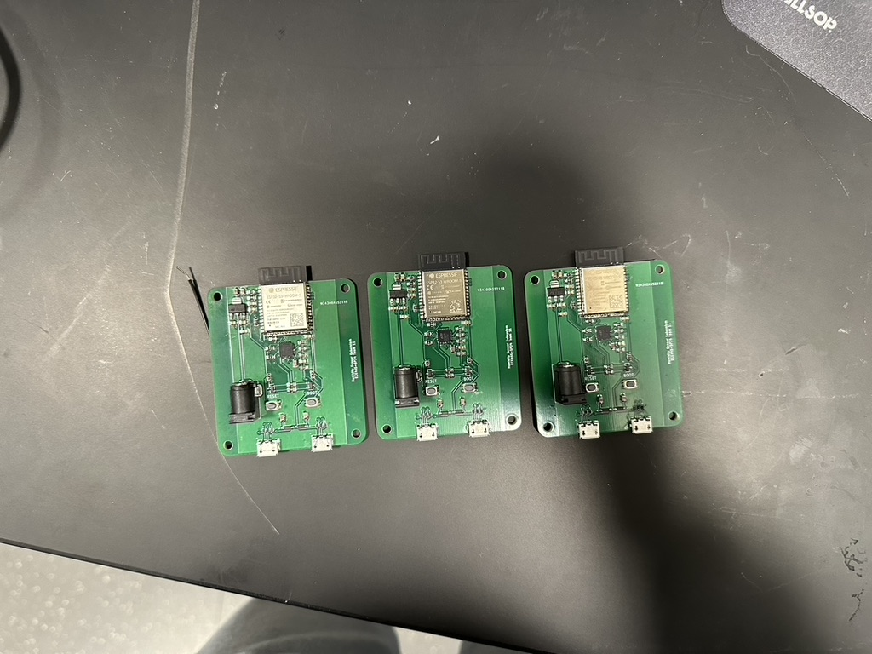

**Thursday April 11, 2024**

**Objective: Test humidifier PCB, figure out what is wrong**

Today, I decided to solder the humidifier board with our replenished parts. The reason why I did not want to wait until Saturday to do it with Jalen is because there will be no time to buy new parts on Saturday and have it ship.

I finished soldering the board with just one relay like last time. However, before soldering the ESP32, I tested the voltage divider from the water level sensor to make sure it outputs 3.3V to the ESP32.

$$V_{out}= V_{in}*\frac{100}{100+200}$$

$$V_{out}=3.333V$$

After the verification with the multimeter, I was comfortable to solder the ESP32 on.

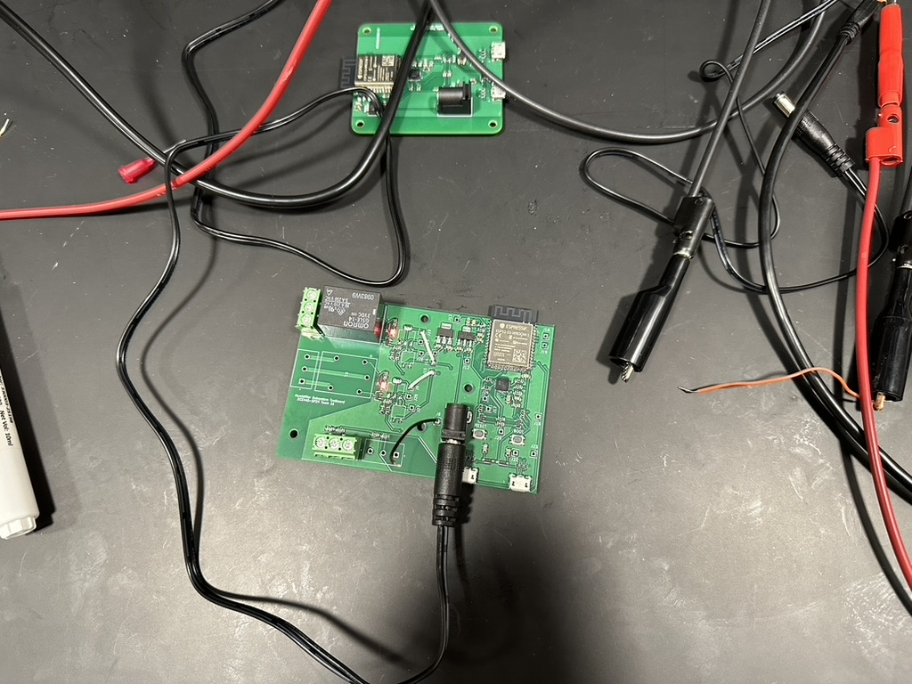

Upon testing the board, I can see that it is fully working. I realized that the first time that I did it, the board fully works. Maybe it was late that night, but I got GPIO number, and the pin number confused on the program.

I also bridged the connection in the through holes. This will avoid the optocoupler, which did not work. Also, because the ground is shared, the optocoupler was pointless.

In the day, I went to the machine shop the bring them my new AC/DC converters with the isolation cage. Also, it was to check in with Gregg on when they will start working on the project.

Gregg asked around the shop for who was interested and available to work on our project. He assigned us to Skee Aldrich. I went over the components with Skee and the functionality. We picked a clear box for the humidifier subsystem. This was the only box left that can fit the components. It looks good.

**Friday, April 12, 2024**

**Objective: Work on the box containing humidifier PCB, test input voltage**

Today, Jalen and I was going to wire the board up. We needed to test the AC components. At around 15:50, I went to the machine shop to get some parts for us to use. Skee had already left, but I asked Gregg if I could borrow the parts. Gregg said sure, but I had to return it Monday morning at 8:00am. I promised him that I will do it.

With the box, Jalen and I mock-placed the components. 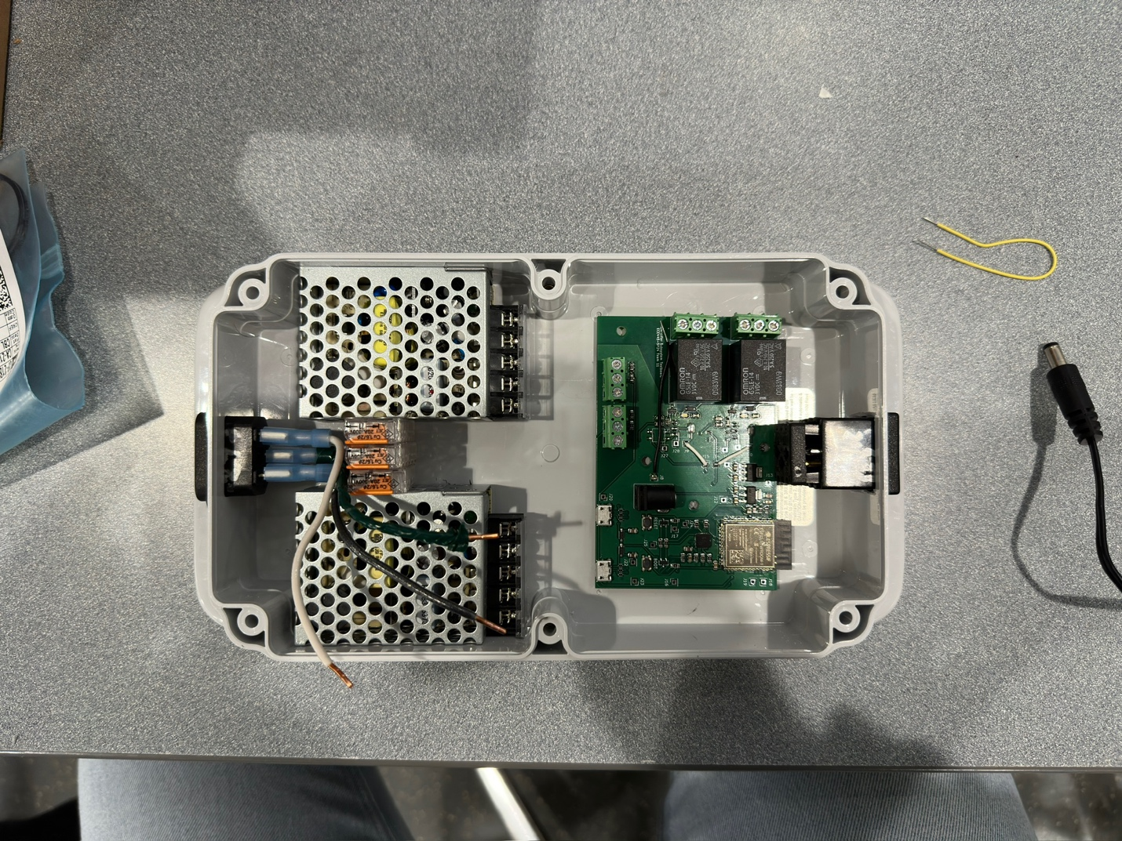

We also tested the functionality of the transformers. We determined that the 5V transformer was not working, as the adjuster only output 4.2V.

I updated the block diagram again. This time, I am reflecting the switching regulated supply. There will be two switching regulated supply. The first one will take in 120V and output 5V, while the other takes in 120V and outputs 12V.

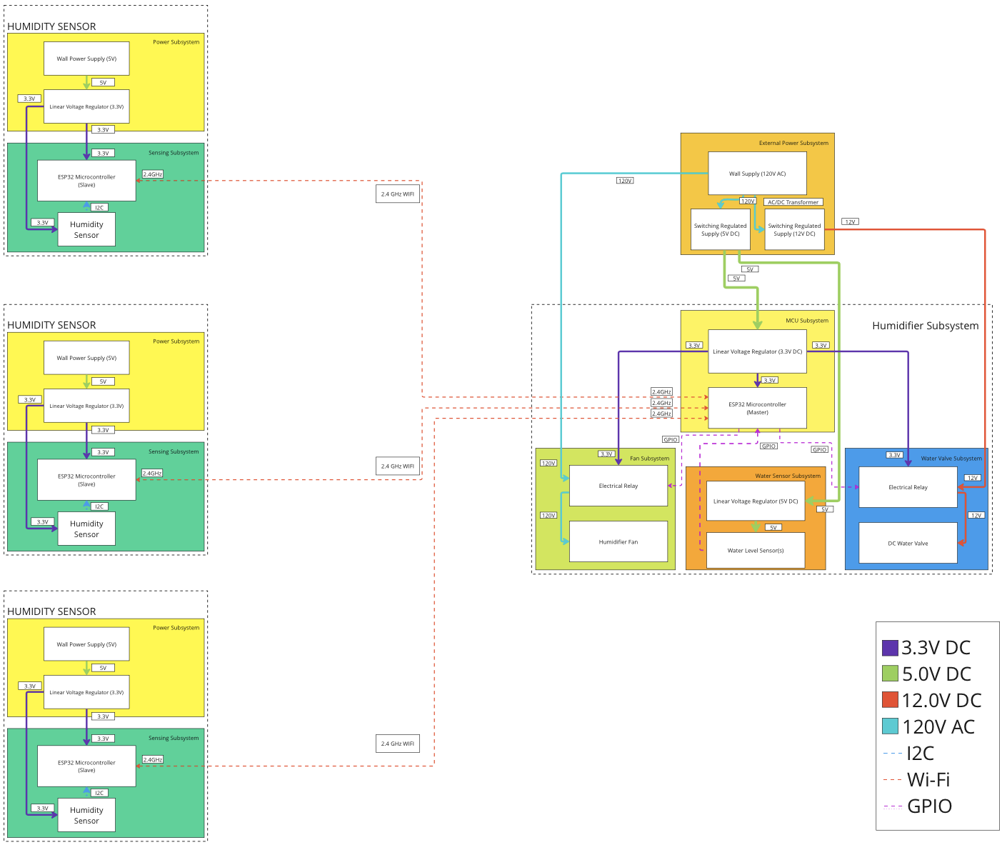

**Sunday, April 14, 2024**

**Objective: Resolder second humidifier subsystem PCB with new parts**

Today, I finished up soldering the rest of the humidifier subsystem’s PCB. I added the remaining relay and the water level sensor input. This was because we have a mock demo on Tuesday. 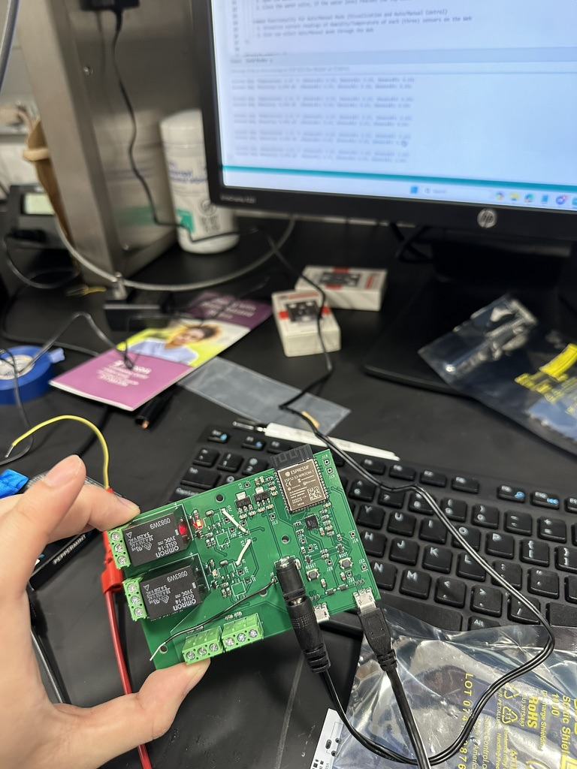

Tonight, Woojin got the HTML webpage up. Our data can be read on the website, though a little bit low.

**Monday, April 15, 2024**

**Objective: Give parts to Skee, wire up box**

I went to ECEB at 7:55am to hand the parts to Skee. Gregg was very happy that I showed up on time in the morning.

Skee finished up the boxes today, so I can work on wiring them up today. However, he still needed to work on the water tank for us to demo. I also noticed that he did not make holes for the sensor subsystem boxes. The holes are for the power cables to go through. I will bring it to him tomorrow morning.

I spent the night wiring the humidifier box up.

**Tuesday, April 16, 2024**

**Objective: Test enclosure for PCB in the humidifier subsystem, meet Surya for mock demo**

Early this morning, I finished wiring the whole humidifier subsystem. Prior to plugging the humidifier in, I used the non-contact voltage tester to see if there are voltage leakage. There was not, so I plugged the humidifier in. Using Woojin’s webpage, the fan was able to be turned on and off. I was happy with this result.

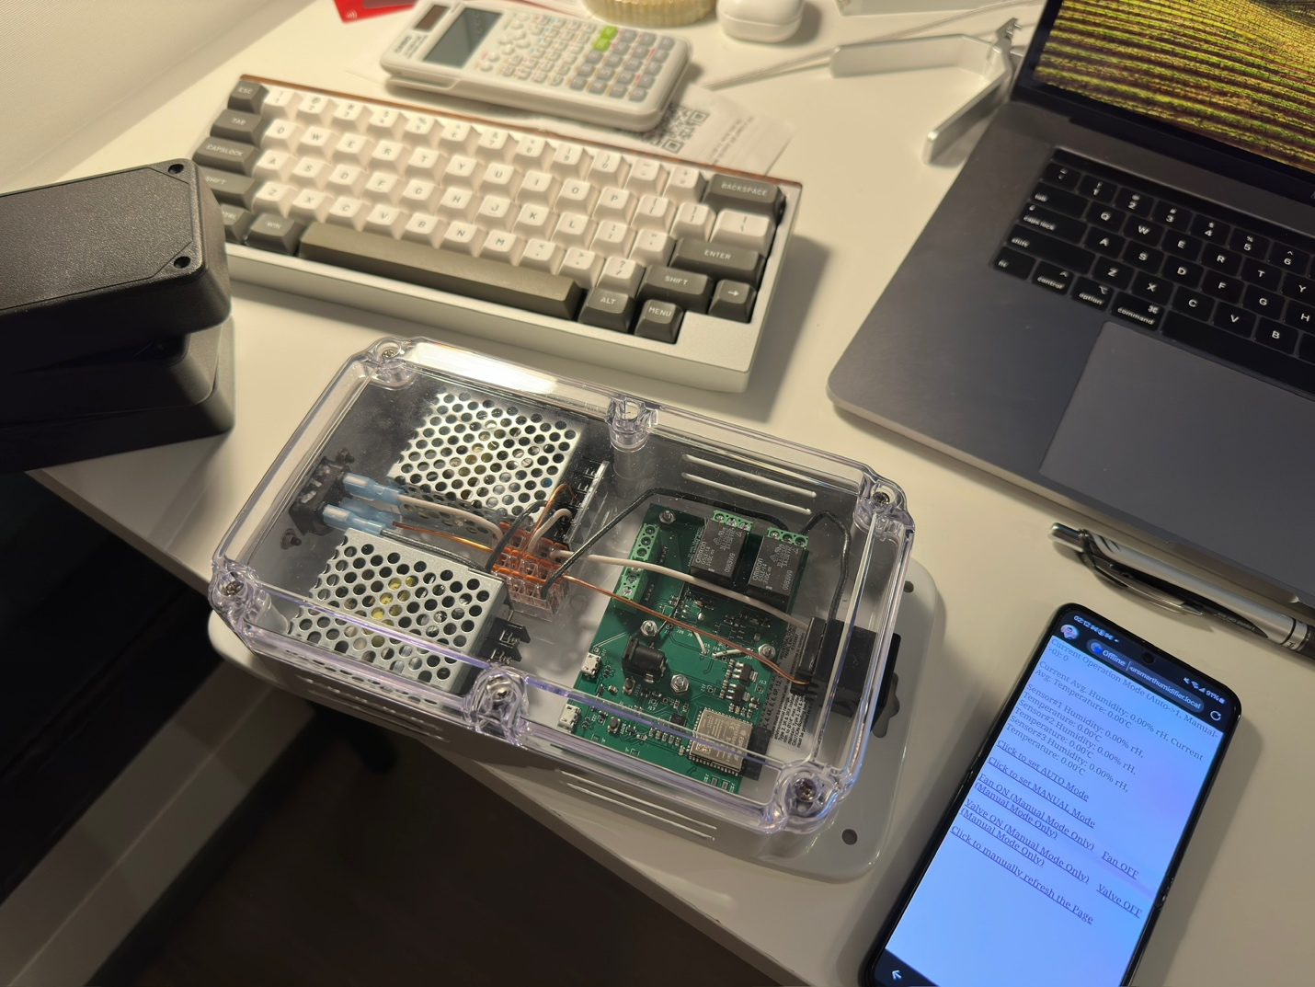

In the afternoon, I spent my time wiring the water level sensors and the wires for the water valve. I bought the parts from the ECE supply store. I also heat-shrunk the wires. Later in the afternoon, we did a practice presentation with Surya. Surya told us to clean up the wiring. I will heat shrink the wiring some more.

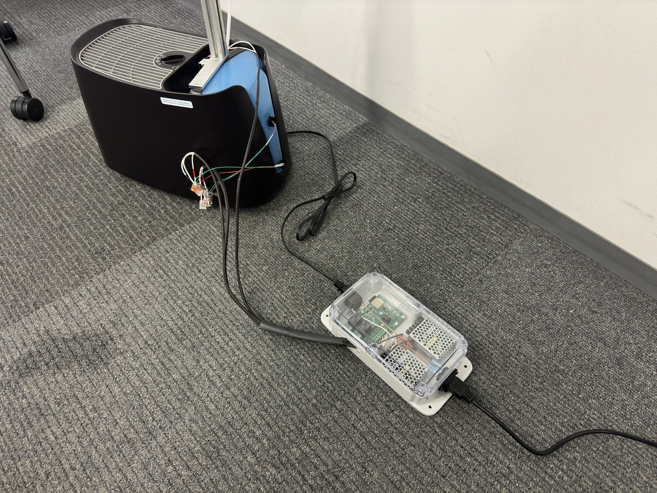

**Wednesday, April 17, 2024**

**Objective: Heat shrink wires, join some wires**

I cleaned up the wiring a bit with ½ inch heat shrink. However, the heat shrink was only 6 inches long. As a result, I had to use multiple sections. The heat shrink was from different manufacturers, so the colors were different. I was not pleased with the result, so I bought some marine grade waterproof heat shrink from Amazon. The order will arrive Friday.

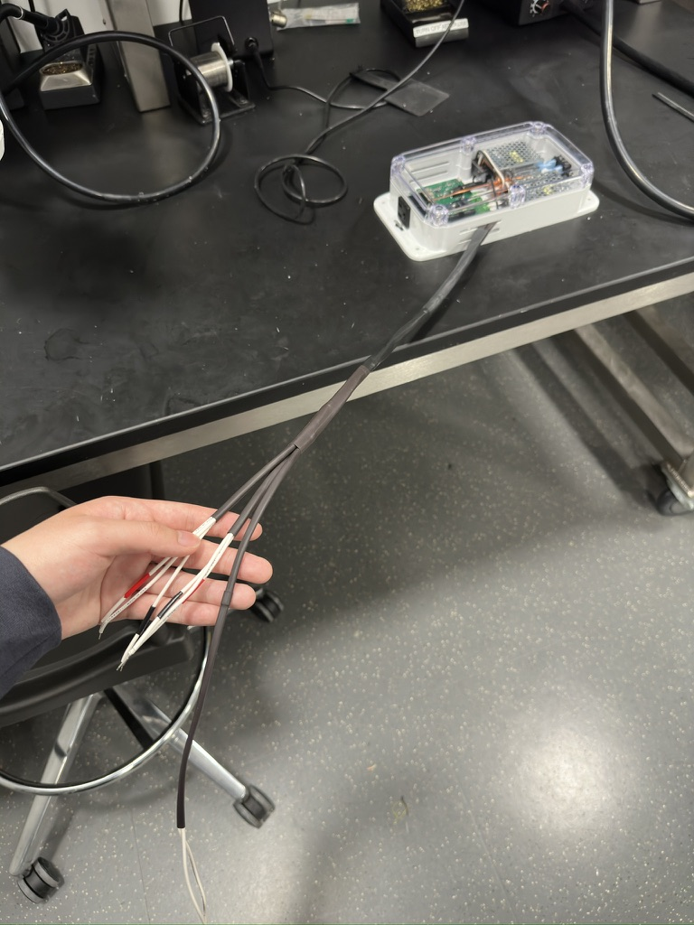

**Friday, April 19, 2024 and Saturday, April 20, 2024**

**Objective: Heat shrink wires, test voltage and temperature output, make tables and graphs**

Lingxian Cai, a friend of mines fried their ESP32, and a new one will not arrive until Monday. So, I gave our last spare one to him.

With the new 10ft long heat shrink, I worked on heat shrinking the wires into one. I also planned to connect the water level sensors.

The heat shrink was horrible to get on the wires. The waterproof heat shrink had a tacky layer inside. As a result, sliding the heat shrink over the wires was very difficult. It took me 2 hours to get it over our 2.5 feet of wire.

After that, I connected the water level sensors to the wires I just heat shrunk. Originally, I wanted to crimp the wires, as that allows the proper connection. It is used in aerospace. However, the crimps were too large for the heat shrink. As a result, to keep the clean look, I soldered the wires. I stripped it 2 inches so that the contact surface will be maximized.

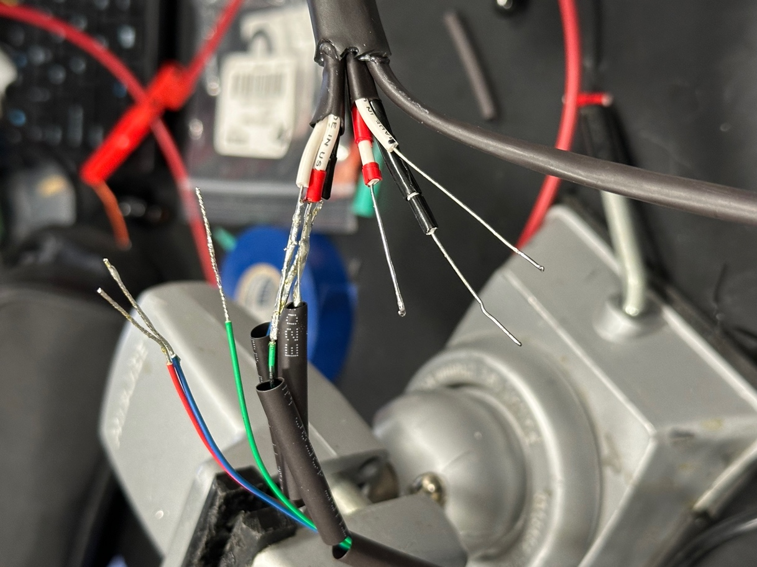

After soldering, I did continuity testing to make sure the connections were good before heat shrinking the connections. 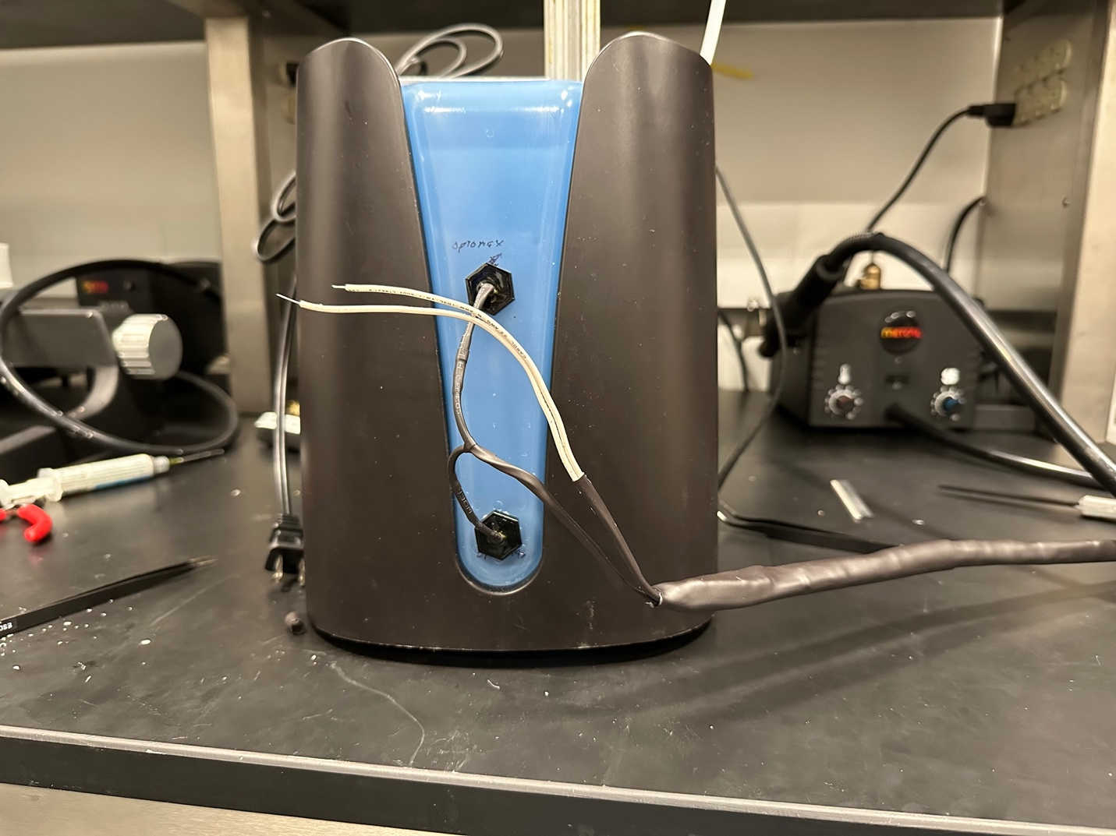

The result was very clean. For the water valve wires, I need to go to the supply store to get two new female connectors, as the original was damaged when I was pulling the heat shrink over the wires.

Later at night, I worked with Woojin and Jalen on our presentations and handouts for the demonstration. The demonstration is April 23, 2024, at 9:30am in 2072.

Woojin also worked on verifying the runtime and proving that 44ns is unrealistic. He also updated the water level sensor algorithm. I discovered a couple days ago when demonstrating to Surya on the mock demo that the algorithm did not make sense. Previously, it would only fill water when both sensors detect no water. However, when the lowest sensor detects water, it will stop filling. As a result, the water level will never go to the top sensor. Woojin also made an offset algorithm for the humidity data and the temperature to compensate for the box design.

Jalen and I also did our RV table verifications. Below are the graphs of data that we collected for the voltage input over 1 hour:

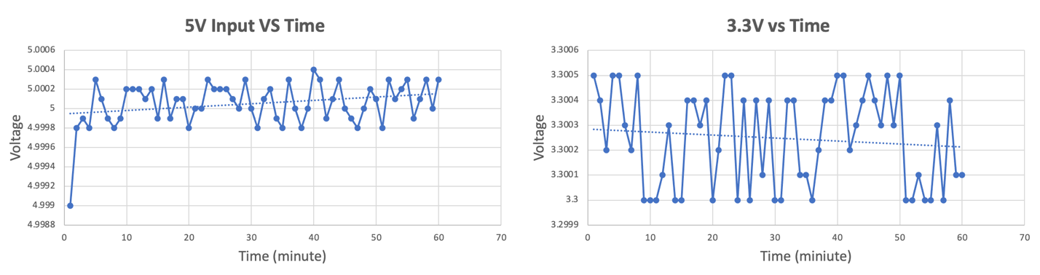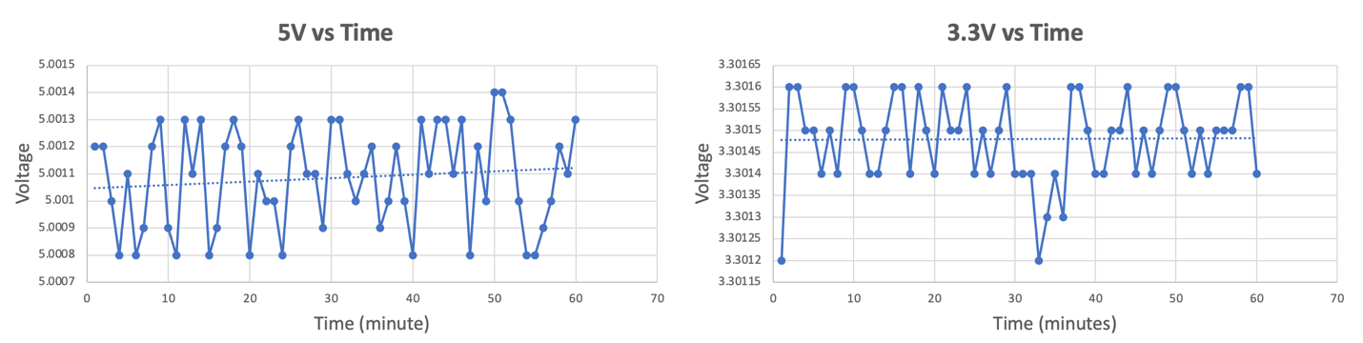

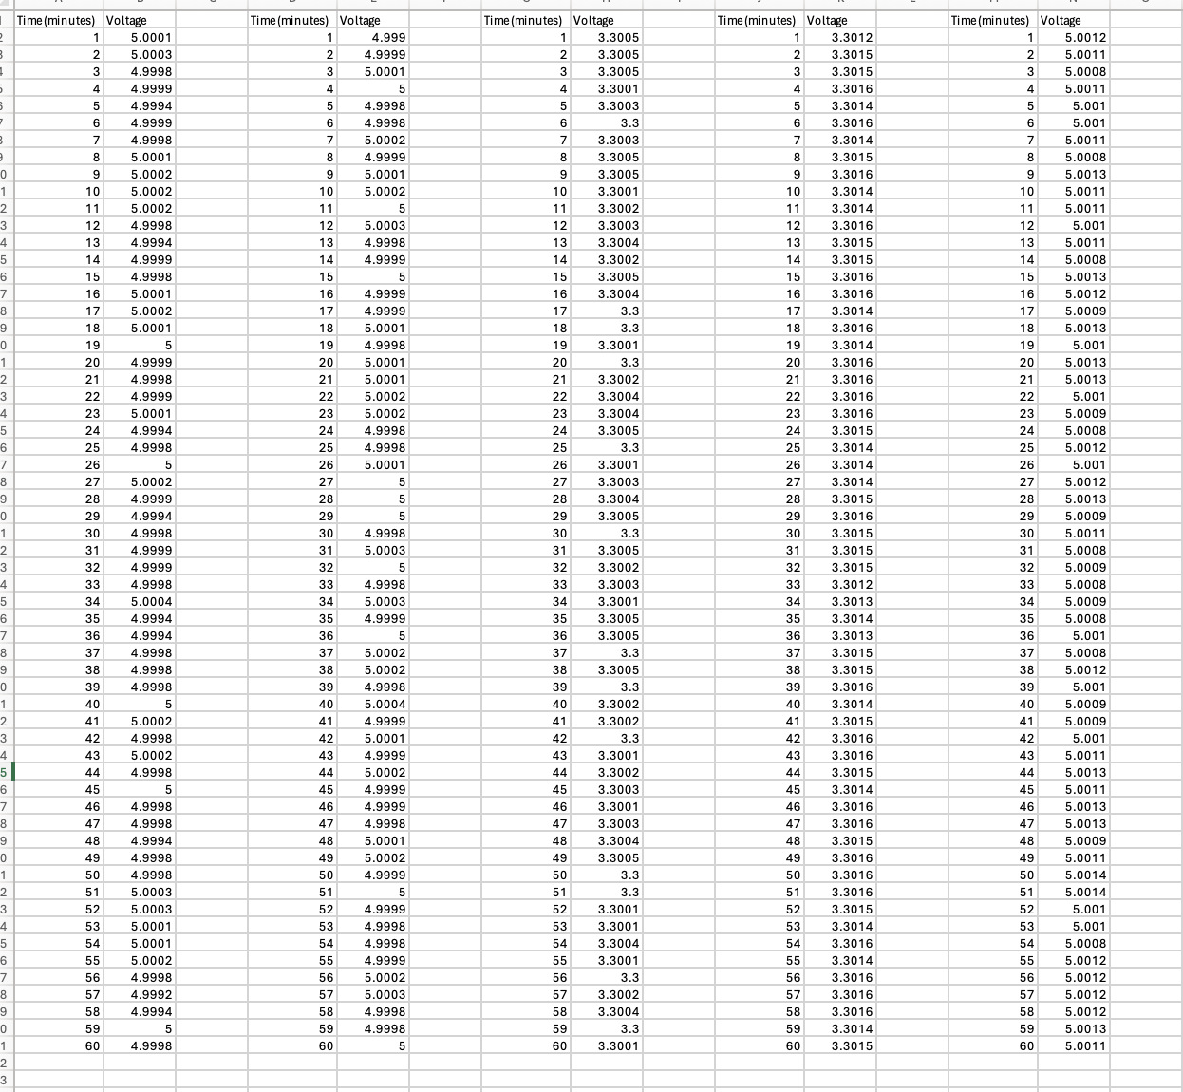

We were also able to confirm that our three sensor readings matched that of the commercial humidity and temperature sensor from Amazon.

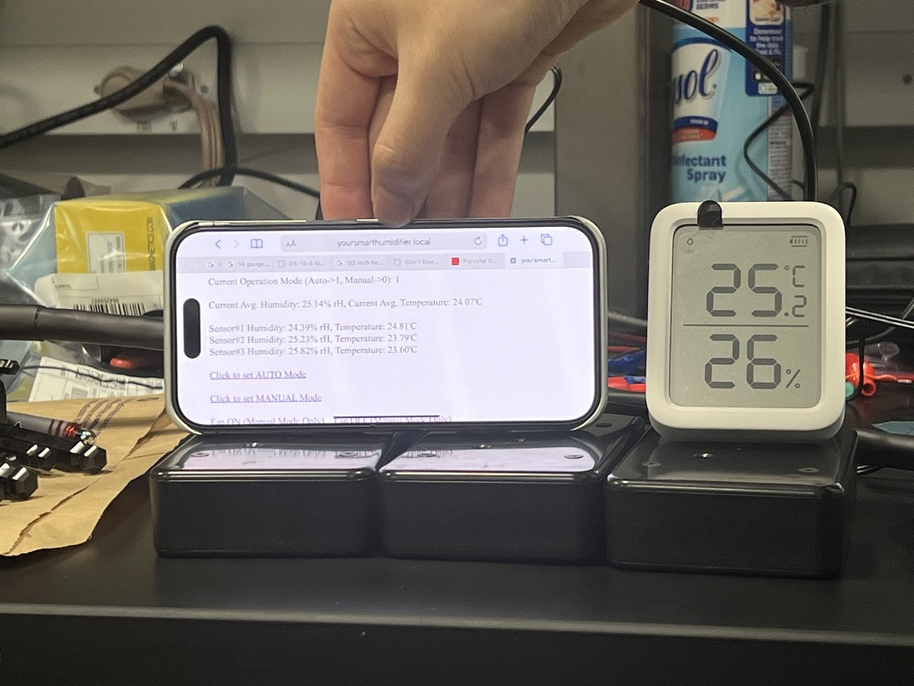

Woojin did the runtime test, and the runtime was 90,000ns for a two way communication. This is around 45,000ns for SHT45 to the humidifier subsystem’s ESP32. This is because there is a lot of data to pack and unpack, as well as other delays when running the code. Therefore, we verified that the 44ns was unrealistic theory.

**Monday, April 22, 2024**

**Objective: Print handout at FedEx, buy parts at Home Depot, finish wiring**

Today, I printed 4 copies of the handout at FedEx. I printed the copies using 32g paper for a more professional and premium feel.

I also went to Home Depot again to pick up heat shrink, 0.250 female connectors for 18-22 gauge wires, and water resistant heat shrink.

At night, we double checked the PowerPoint and did some practice presentations. Woojin added 8 sources to the bibliography. Woojin needs more practice on the presentation.

While Woojin left early, Jalen and I finished the water pump’s wiring. We tested everything in the humidifier subsystem and confirmed everything worked.

**Tuesday, April 23, 2024**

**Objective: Present demonstration**

After going home, I continued to look through the PowerPoint to make sure everything looks correct. I added descriptions to the photos in the PowerPoint. I also told Woojin what to say for the 44ns. I made sure all our verifications were met. I also practiced speaking every slide on the PowerPoint, so that I know everything.

In the morning, I arrived at ECEB at 8:30. I got the study room across the ECE411 OH room. I plugged the sensors in and made sure everything worked. Woojin came in, but Jalen was really late. Luckily, he arrived on time for the presentation.

The presentation went spectacularly. Professor Schuh and the second TA were impressed with our project. The professor’s face lit up when we unplugged one sensor, and the average was recomputed with just two sensors. Surya said in text that we earned 10 points for complexity!

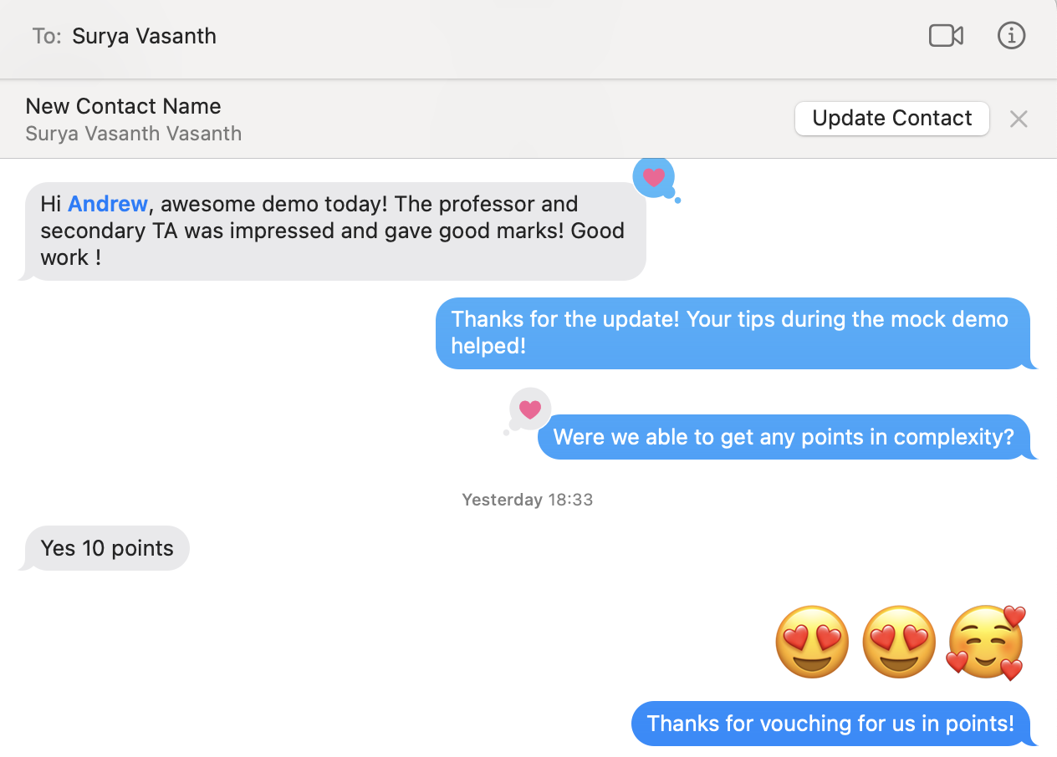

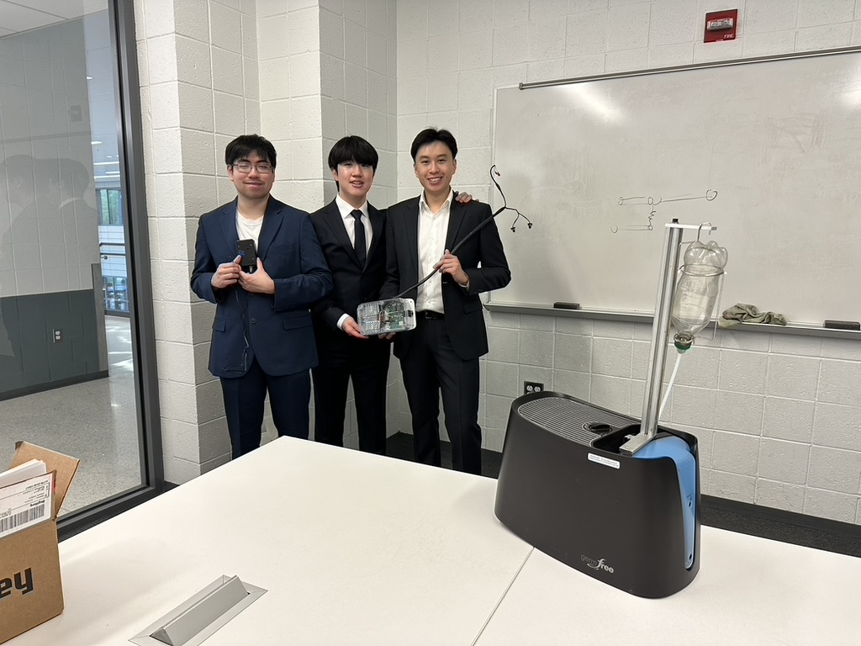

**Friday, April 26, 2024**

Today Jalen and I filmed the extra credit video together. The reason why Woojin could not attend was because he had badminton.

**Saturday, April 27, 2024**

**Objective: Prepare for final presentation, 3D scan product**

We met today to work on the final presentation PowerPoint. There was not a lot of things to add, as our previous PowerPoints already had graphs and data. We did, however, add schematics of our PCB and added a slide about the challenges we faced. On top of that, I 3D scanned our humidifier and the sensors. This will be used on the PowerPoint as a looping video.

**Monday, April 29, 2024**

**Objective: Present final presentation**

Today was our final presentation. We spoke for 20-21 minutes, so the timing was very good. However, Professor Schuh asked a very tricky question at the end of the presentation. We had one bullet point stating that we can modularize our humidifier by removing the water level sensors and the water valve. However, Schuh brought up doesn’t that point negate one of our high levels. I did not want to answer his question directly, so I danced around the question. The reason why I put the bullet point was because we need to design a new humidifier from the ground up to have our full working project. However, we do not have the funding for that.

**Tuesday, April 30, 2024**

**Objective: Work on final report**

Today, we worked on the final report with Woojin and Jalen. Most of our report was a carry-over from the design document. However, some things had to be updated, as we are now using relays and 5V as input to the PCB, for example. We updated our labor table, as seen below:

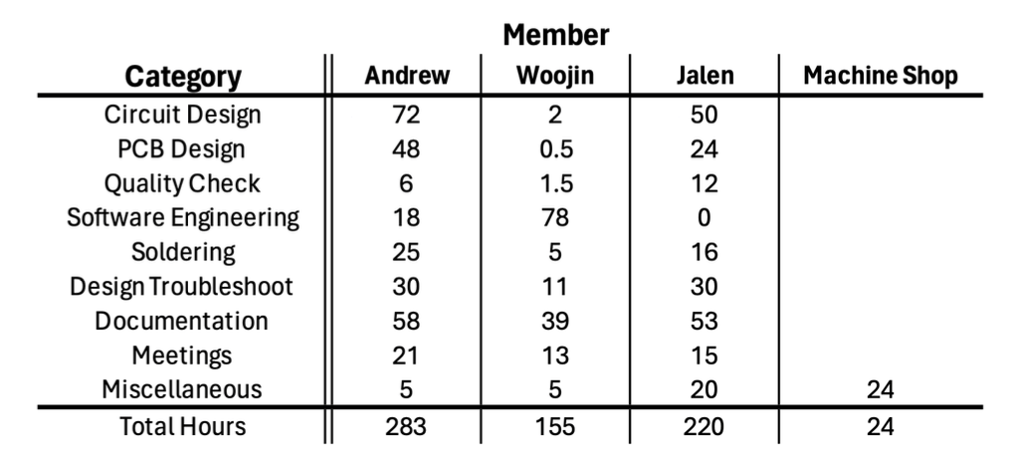

We estimated that there are 24 hours of work done by the machine shop. This is because the machine shop worked on our project for three 8-hour workdays. We also discussed the total amount of hours we each put in the project. There were some slight discomforts when discussing the hours that Woojin spent on work. Though we agreed to put 2 hours and 0.5 hours for Circuit Design and PCB Design for Woojin, this is just a “show of face” to Woojin. The reason is that he basically did 0 hours for both of those two categories. He does not even have the KiCad files on his computer and is not clear about how the circuit works. He did do software engineering, but 78 hours is a stretch. The software he wrote was primarily using libraries and example code. He claimed it took him 5 hours to figure out GPIO signals, but not only did I send him example code at the beginning of the semester, but GPIO read and write only takes 15-30 minutes to learn. Woojin did help solder for 5 hours and did help with troubleshooting. But the amount of work he performed was not satisfactory, as he was always busy with other classes.

Jalen’s hours are accurate, as I worked closely with him all semester.

At the end of the night, we realized that we still had to cross-reference figures and citations. We decided to finish that the next day.

**Wednesday, May 1, 2024**

**Objective: Conflict between members on labor table, turn in final report**

Woojin was not able to make it to help us do the cross-reference, so Jalen and I worked on it earlier. It took us two hours to finish, and it was just as I predicted yesterday.

We submitted the paper. However, at 17:30, Woojin called me and asked me to take down the labor table. He says that while some teams like Fall 2022’s CHARM has it, many other teams do not have it. I got the feeling that he was uncomfortable and embarrassed with the amount of work that he did. I did not like his idea because that would discredit all the work that Jalen and I did. Woojin says that we can just include the total hours, in fact he can even decrease his hours to 145. I told him to talk to Jalen about it. If Jalen agrees, then I will change it. Jalen agrees since he did not want to cause trouble, and I updated it to the table below:

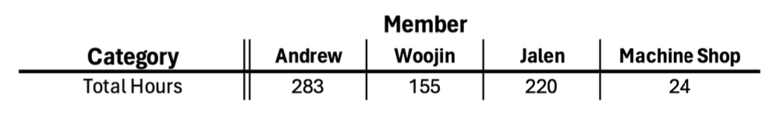

I kept it at 155 hours for Woojin as I feel like it honors his work. However, Jalen and I are not very satisfied with this. However, I did push it on the website as we agreed on. I left the first version as “confidential”.

Woojin went on Discord to ask us to remove the original version from the server. I said I will not do that, as it is already confidential. He tried calling me, but I ignored his call.

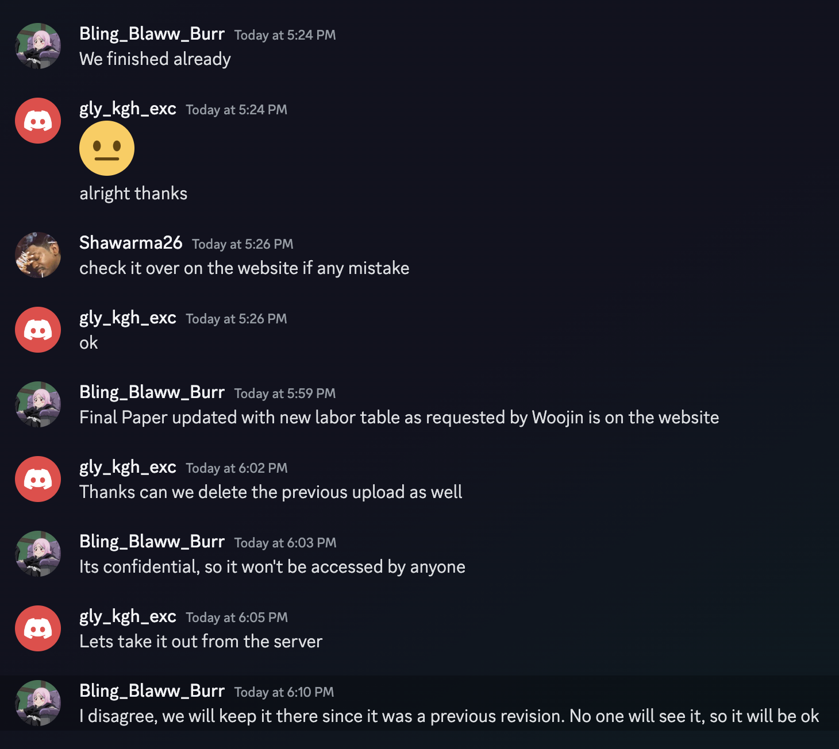

I suggested we do a group call at 22:00 so that he can beat around the bush and tell us what he really wants.

During the call, I suggested that we make a compromise where Jalen and I keep our breakdown of hours, but Woojin will have his blanked out. He also stated that he though 155 hours is too much and should decrease his software engineering hours to 40 hours. This will make his new total 117 hours. Jalen and I agreed to this. Also, we removed the original document from the ECE445 page as requested by Woojin. I think Woojin does not want the public to know what parts he worked on specifically. Below is the final table:

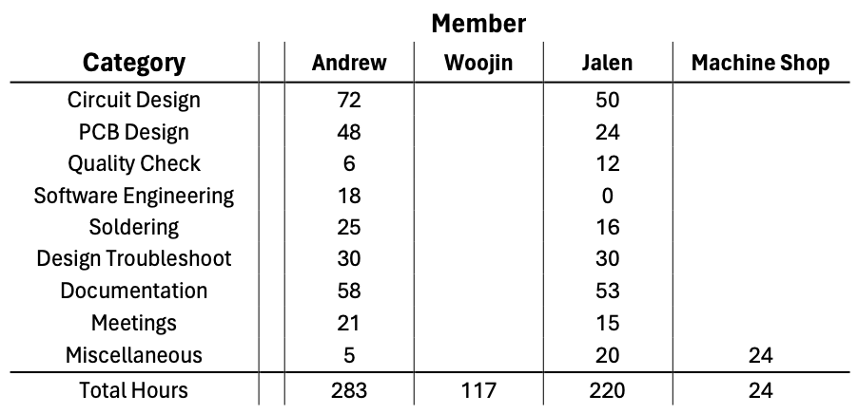

To upload this Word document to GitHub, I had to find a way to convert the text to MarkDown, which is GitHub’s text file format. I found Pandoc that can do it for you. By using the command:

“pandoc --extract-media ./myMediaFolder input.docx -o output.md”

I can export the text and media and push it to GitHub.

**References**

1. F. Hecht, “Wifi Propagation,” *freedom*, 2017. https://doc.freefem.org/tutorials/wifiPropagation.html (accessed Mar. 29, 2024).
2. M. Marwell, “Issues with the I2C (Inter-IC) Bus and How to Solve Them,” *DigiKey*, Aug. 09, 2018. Accessed: Mar. 29, 2024. [Online]. Available: https://www.digikey.com/en/articles/issues-with-the-i2c-bus-and-how-to-solve-them
3. MetaGeek, “Wi-Fi and Non Wi-Fi Interference,” *MetaGeek*, 2024. https://www.metageek.com/training/resources/wifi-and-non-wifi-interference/ (accessed Mar. 29, 2024).
4. A. V. Arundel, E. M. Sterling, J. H. Biggin, and T. D. Sterling, “Indirect health effects of relative humidity in indoor environments.,” *Environmental Health Perspectives*, vol. 65, no. 65, pp. 351–361, Mar. 1986, doi: 10.1289/ehp.8665351.
5. V. Perrone *et al.*, “The Epidemiology, Treatment Patterns and Economic Burden of Different Phenotypes of Multiple Sclerosis in Italy: Relapsing-Remitting Multiple Sclerosis and Secondary Progressive Multiple Sclerosis,” *Clinical Epidemiology*, vol. Volume 14, no. 14, pp. 1327–1337, Nov. 2022, doi: 10.2147/clep.s376005.
6. IEEE, “IEEE Code of Ethics,” *IEEE Code of Ethics*, 2020. https://www.ieee.org/about/corporate/governance/p7-8.html (accessed Mar. 29, 2024).
7. University of Illinois, “Salary Averages,” *UIUC*, 2022. https://ece.illinois.edu/admissions/why-ece/salary-averages (accessed Mar. 29, 2024).
8. Environmental Protection Agency, “Care for your air: A guide to indoor air quality,” *US EPA*, Aug. 07, 2023. https://www.epa.gov/indoor-air-quality-iaq/care-your-air-guide-indoor-air-quality (accessed Mar. 25, 2024).
9. Sensirion, “Datasheet -SHT4x,” *Sensirion*, Aug. 2023. https://sensirion.com/media/documents/33FD6951/6555C40E/Sensirion_Datasheet_SHT4x.pdf
10. A. Sherwin, *ECE445 Team 11 - Sensor Subsystem Schematic*. 2024.
11. A. Sherwin, *ECE445 Team 11 - Humidifier Subsystem Schematic*. 2024.
12. Espressif, “ESP32-S3-WROOM-1 ESP32-S3-WROOM-1U Datasheet,” *Espressif*, 2023. https://www.espressif.com/sites/default/files/documentation/esp32-s3-wroom-1_wroom-1u_datasheet_en.pdf
13. IEEE, “IEEE Code of Ethics,” *IEEE Code of Ethics*, Jun. 2020. https://www.ieee.org/about/corporate/governance/p7-8.html (accessed Mar. 26, 2024).
14. Espressif, “sch_esp32-s3-devkitc-1_v1_20210,” *Espressif*, Apr. 13, 2022. https://dl.espressif.com/dl/schematics/SCH_ESP32-S3-DevKitC-1_V1.1_20220413.pdf (accessed Mar. 26, 2024).
15. A. Sherwin, *Sensor Subsystem Block Diagram (Close-Up)*. 2024.
16. A. Sherwin, Humidity Subsystem Block Diagram (Close-Up). 2024.
17. D. Workshop, “ESP NOW - Peer to Peer ESP32 Communications,” DroneBot Workshop, Apr. 03, 2022. https://dronebotworkshop.com/esp-now/
18. K. Rembor, “Adafruit Sensirion SHT40, SHT41 & SHT45 Temperature & Humidity Sensors,” Adafruit Learning System, Feb. 04, 2021. https://learn.adafruit.com/adafruit-sht40-temperature-humidity-sensor/arduino
19. cplusplus, “std::chrono::high_resolution_clock::now,” cplusplus. https://cplusplus.com/reference/chrono/high_resolution_clock/now/ (accessed Apr. 20, 2024).
20. cplusplus, “std::chrono::nanoseconds,” cplusplus. https://cplusplus.com/reference/chrono/nanoseconds/ (accessed Apr. 20, 2024).
21. me-no-dev, “ESPAsyncWebServer/README.md at master · me-no-dev/ESPAsyncWebServer,” GitHub. https://github.com/me-no-dev/ESPAsyncWebServer/blob/master/README.md
22. Tea, “ESP32 Web Server periodic updating problem,” Stack Overflow. https://stackoverflow.com/questions/64610221/esp32-web-server-periodic-updating-problem
23. antepher, “ESP32 Arduino: HTTP server over soft AP,” techtutorialsx, Jan. 07, 2018. https://techtutorialsx.com/2018/01/07/esp32-arduino-http-server-over-soft-ap/
24. ESPRESSIF, “ESP-NOW - ESP32 - — ESP-IDF Programming Guide v5.2.1 documentation,” espressif.com. https://docs.espressif.com/projects/esp-idf/en/stable/esp32/api-reference/network/esp_now.html
25. Center for Drug Evaluation and Research, “Use Caution When Giving Cough and Cold Products to Kids,” *U.S. Food and Drug Administration*, 2018. <https://www.fda.gov/drugs/special-features/use-caution-when-giving-cough-and-cold-products-kids> (accessed May 01, 2024).
26. A. Sherwin, Consumer Visual Aid. 2024.
27. A. Sherwin, Component Visual Aid. 2024.
28. A. Sherwin, Overall Block Diagram. 2024.
29. A. Sherwin, Humidity Subsystem PCB. 2024.
30. A. Sherwin, Webserver Webpage. 2024.
31. A. Sherwin, Sensor Subsystem PCB. 2024.
32. A. Sherwin, RV Table A-1. 2024.
33. A. Sherwin, RV Table A-2. 2024.
34. A. Sherwin, RV Table A-3. 2024.
35. A. Sherwin, RV Table A-4. 2024.
36. A. Sherwin, RV Table A-5. 2024.
37. A. Sherwin, RV Table A-6. 2024.
38. A. Sherwin, RV Table A-7. 2024.
39. A. Sherwin, RV Table A-8. 2024.
40. A. Sherwin, RV Table A-9. 2024.
41. A. Sherwin, RV Table A-10. 2024.
42. A. Sherwin, RV Table A-11. 2024.
43. A. Sherwin, RV Table A-12. 2024.
44. A. Sherwin, Sensor Subsystem Parts. 2024.
45. A. Sherwin, Humidifier Subsystem Parts. 2024.
46. A. Sherwin, Estimated Development Hours. 2024.
47. A. Sherwin, Total Cost. 2024.
48. Engineering IT Shared Services, “Lab :: ECE 445,” *Senior Design Laboratory*, 2020. https://courses.engr.illinois.edu/ece445/lab/index.asp (accessed May 01, 2024).